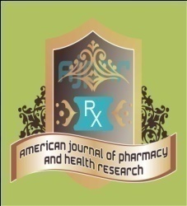
Research Article
AMERICAN JOURNAL OF PHARMACY AND HEALTH RESEARCH
www.ajphr.com
2026, Volume 14, Issue 02
ISSN: 2321–3647(online)

Comparative Study of New Drug Approval Processes in India, US and Canada

Pranali Arun Pawar^{1* ,} Aneri. V. Adsul¹ , Prajakta Arun Pawar¹
YSPM’s YTC, Faculty of Pharmacy, Satara.

ABSTRACT
A regulatory process of drug approval is very important in ensuring that new pharmaceutical products are safe, effective and produced without quality standards. In this review, the approval procedures in India, The US and Canada are compared. This also involves an organized evaluation that is supported by scientists. The three systems aim to safeguard the well-being of the masses by ensuring that medicines reach the patients only when they are well characterized, evidence based, and of the highest quality, irrespective of the system structure, documentation requirements, reviewing period and the regulatory authority roles. This comparative study outlines similarities and specific regulatory aspects to define Indian, U.S., and Canadian drug-approval process.
Keywords: Drug approval process, Regulatory affairs, Pharmaceutical regulations, New drug approval, CDSCO, USFDA, Health Canada, Clinical trials, Regulatory authority, Drug safety and efficacy.

*Corresponding Author Email: pawarpranali469@gmail.com
Received 01 February 2026, Accepted 18 February 2026

INTRODUCTION
The new drug has to undergo two approval processes: the initial approval is on clinical investigations and the second approval is the permission to be promoted. Application to submit clinical trials is then submitted to the relevant regulatory body of the respective country after non clinical drug tests have been conducted to ascertain efficacy and safety. This may be followed by the clinical trials (phase I through phase IV). The studies are conducted to undertake the safety, effectiveness, and dose optimization of the medicaments in human species.^{1,2}
After the clinical trials of the substance, application has been submitted to the regulating body of the concerned country to license the drug to be marketed. The qualified authority should evaluate the use of medication and should only be approved to be sold when the drug is known to be safe and effective to human beings in the state or the advantages of the drug surpass its disadvantages. The laws in the regulation of authorization of new drugs demand that the government has to watch and ensure the safety of a drug after its approval.^{3,4}
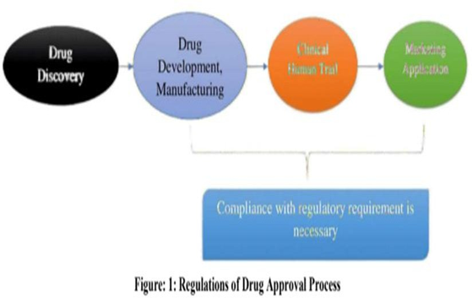
Figure 1: Regulation of Drug approval process
DRUG APPROVAL PROCESS REGULATIONS:
Application to commercially market a new drug made to a regulatory body is known as a New Drug Application (NDA). To receive this authorization a backer should submit early-stage and clinical trial data on drug data analysis and specifics of production process. Various stages of Clinical Trials:
- Animal research on mice, rats, rabbits and monkeys.
- Phase I: Human pharmacology research: Security and acceptability test.
- Phase II is exploratory research where the effectiveness and short-term side effects are viewed.
- Phase III: is the confirmatory trial which confirms benefits of healing.
- Phase IV is a post-marketing trial, which undertakes research following the approval of the medicine.^{5,12}
Upon receipt of the NDA, the agency conducts a technical assessment of the NDA. This analysis will make sure that enough information has been provided in each area in order to support the process of submitting the application. After the review of the NDA, the sponsor can be granted one of the three following actions:
- Unacceptable- this letter identifies the faults and the reasons why.
- Approvable: It implies that the drug is fit to be approved but has some minor problems, which can be addressed, such as marking changes and potential requests to allocate resources to post-approval research.
- Approval: It is an indication that the drug is approved. The regulatory agency also allows the applicant a chance to meet with the agency and explain the weaknesses in case the measure undertaken is justifiable or otherwise.^{9,12}
INDIA DRUG APPROVAL PROCESS:
The Drug and Cosmetic Act of 1940 and Rules that were formulated in 1945 were authorized by the Indian parliament to control the importation, production, marketing and distribution of pharmaceuticals and cosmetics. The Drugs Controller General India (DCGI) and Central Drugs Standard Authority Organization (CDSCO) were put in place. In 1988, the Indian government made an addition of Schedule Y to the 1945 Drugs and Cosmetics Regulations. Schedule Y gives, by clinical study methods and criteria, which were updated in 2005 to meet the internationally agreed-upon methodology. These changes involve the definition of Phase I -IV trials and assigning sponsors and researchers with certain responsibilities.^{5,7}
The clinical studies were also separated into two other groups in 2006. Under a single grouping (category A) clinical tests can be done in most of the markets where a competent and developed regulatory framework exists; but the rest of the markets that undergo clinical tests come under a separate group (category B) with an exception of one Clinical trials that are under category A (approved in the United States, Britain, Switzerland, Australia, Canada, Germany, South Africa, Japan and the European Union) can be fast tracked in India and are expected to pass in less than two months. The category b clinical trials are under further scrutiny and will be approved in 16 to 18 weeks. Besides the data of chemistry, production, management, and animal studies, a written application to carry out clinical studies in India has to be submitted to DCGI with a request to apply, the design of the clinical study, the brochures of the researcher, and consent forms.^{6,8}
Phase I clinical trials are conducted on healthy human volunteers who must submit a copy of their application to the ethics board to establish how much dosage can be administered to individuals, side effects, etc. The medicinal applications and effective dose ranges are done through phase II trials the trials involve 10-12 people at each dose level. Confirmatory trials (Phase III) are done in approximately 100 patients (in 3-4 canters) in order to produce information regarding the safety and efficacy of the drug. Phase III studies have to involve at least 500 subjects. In the event that the new drug is not in any other facilities, patients are divided between ten to fifteen facilities.^{5,6}
The registration of the new drug occurs after the clinical trials are done with the form #44 and voluminous pre-clinical and clinical testing data. In addition to information concerning security and efficacy, extensive information concerning the marketing stance of the medication in other countries is also needed. There is also the need to state the information on the item monograph, labels, boxes, samples, testing methods and prescription. When NDA is approved and a company is permitted to distribute and market the product, the product is believed to be in Phase IV trials, in which new uses or populations, long-term effects, etc., are being tested.^{7,2}
Approval procedures of drugs differ in countries. In some nations, the control of pharmaceuticals is located in one organization which handles all the oversight roles, including, obtaining approval of new drugs, permission to manufacture and evaluate manufacturing plants. As an example, in the United States, all these functions are managed by FDA. Nonetheless, not all of these tasks are performed by one individual in a particular county. regulatory agency which is the case in India where the state and centralized bodies are distributed with the work.^{18,24}
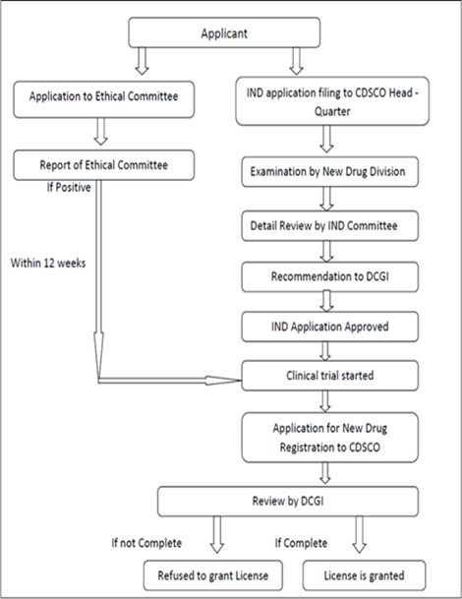
UNITED STATES DRUG APPROVAL PROCESS:
In its attempt to approve new pharmaceutical products, the US has one of the most rigorous and comprehensive systems of control. The standards that are established by the U.S. Food and Drug Administration (FDA) are regarded as one of the toughest and most rigorous in the world. These regulatory standards always ensure that there is a high likelihood of clinical evidence, strict safety testing and a thorough analysis of the benefits of therapy before any medication can be approved to be used by the rest of the population. Consequently, the drug approval process in the U.S is often considered as the global benchmark in ensuring the Caliber, efficacy, and safety of new pharmaceuticals.³
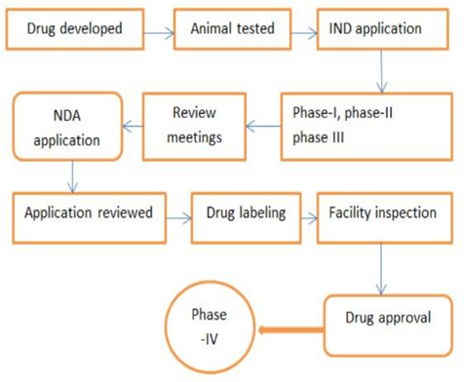
1. Investigational New Drug Applications (IND).
2. New Drugs (NDA) Application.
The United States Food and Drug Administration (USFDA) has been sent these two regulatory submissions to have their comprehensive examination and evaluation. Although the NDA is submitted to seek marketing approval after completion of clinical trials, IND application allows a sponsor to initiate human clinical trials through demonstration of preliminary safety and scientific reasons. These applications together constitute the basic paperwork that FDA requires in determining the safety, efficacy, and overall quality of a new pharmaceutical product before its market introduction.^{9,10}
1. Investigational New Drug Applications (IND):
To permit the initiation of clinical trials with human subjects, the U.S. Food and Drug Administration (FDA) have to submit an Investigational New Drug (IND) application. This submission is submitted after the medication candidate has demonstrated acceptable safety in preclinical (animal) studies. The organization that is responsible to create and submit the IND, also referred to as the Sponsor, may be a pharmaceutical company, academic or individual researcher. The Sponsor can request the FDA to meet with them in an IND before filing the IND. In this discussion, it will provide an opportunity to discuss several key aspects of the development program, including:
Animal studies that should be used to determine the safety of the planned clinical trials were sufficient and designed.
- The proposed protocol of the clinical trial, including the population of patients, methods and objectives of the study.
- The chemical, manufacturing, and control (CMC) information of the investigated drug that ensures the regular and safe production of the product.^{3,9,10}
By attending a pre-IND meeting, the Sponsor will be able to reinforce the whole IND filing, clarify regulatory expectations, enhance research planning. The FDA assistance assists in better clinical trial protocols design, organization of the data collection process, and maximization of animal research. The graphic presented below shows a comprehensive flowchart related to the IND filing and review process.^{3,12}
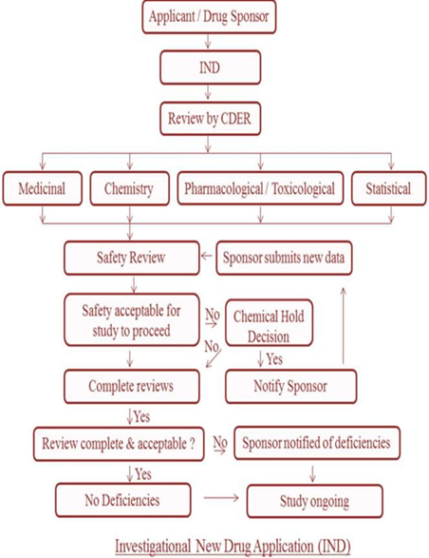
IND Application Types:
- The most common form of IND is investigational IND that a sponsor prepares to initiate clinical studies with an aim of obtaining marketing approval in future.
- Emergency IND (EIND): Typically, in a case of a single patient, it allows the FDA to grant approval of the use of an investigational drug in an emergency in cases where time to submit a standard IND does not exist.
- Treatment IND: Submitted in order to provide patients with serious or life-threatening conditions with no access to any other therapies more access to the experimental drugs with promising results in clinical trials.¹⁹
2.New Drug Application (NDA):
The New Drug Application (NDA) system is the main regulatory framework in the US that controls the commercial availability of drugs. The FDA must approve a new medication based on evidence of its effectiveness and safety before it can be legally sold in the country. After completing Phase I through Phase III clinical trials, the sponsor submits a detailed NDA package for evaluation. The pharmaceutical company collects all scientific, clinical, and quality-related data into the NDA and sends it to the FDA once the clinical development phase is finished. The application provides a complete record of all research findings during the drug-development process. The FDA usually makes a decision about a year after receiving an application, though review times can vary based on the complexity of the application or if it gets priority review.
The NDA must include detailed information about the product's chemistry, manufacturing, and controls (CMC), such as the drug's formulation, stability, manufacturing processes, labelling, and packaging. Along with a thorough statistical analysis of clinical trial data, the submission describes the drug's pharmacology, toxicity, and pharmacokinetic properties. A typical NDA may contain around 100,000 pages of documentation because so much information is needed to prove the drug's safety and therapeutic value.
The company files an NDA if clinical trials show that a new medication is sufficiently safe and effective without posing unacceptable risks to patients. The NDA is the official request made to the Food and Drug Administration (FDA) in the United States for permission to produce, sell, and distribute the medication domestically. This submission includes all scientific, clinical, and quality-related data collected during the development program. The accompanying image illustrates the entire NDA process.
An NDA contains lengthy sections discussing the drug's quality, safety, and effectiveness, along with a complete summary of the whole submission. It includes detailed information about the patient groups studied, the conditions treated, dosing schedules, treatment duration, and the clinical outcomes measured. All adverse reactions, side effects, and safety concerns are carefully documented.^{9,12}
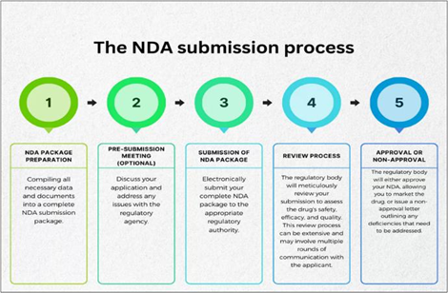

DRUG APPROVAL PROCESS IN CANADA:

The Canadian system of approval of pharmaceutical items is regulated by the Food and Drugs Act which is a legislative framework aimed at protecting the health of the population through regulation of distribution and sale of foods, pharmaceuticals, medical devices, and cosmetics. This regulatory framework ensures that every medicinal product introduced to the Canadian market meets many strict requirements regarding quality, safety, and efficacy before they are made available to the customers.^{14,15}

Health Canada manages this process of clearance by having the Health Protection Branch (HPB) which is the body that evaluates new drug applications and provides monitoring of post-market safety. The HPB also measures manufacturing and quality-control processes, reviews scientific information generated in the course of preclinical and clinical studies, and ensures compliance to national regulatory standards by products. Canada has an effective mechanism that is meant to protect the people and ensure that only pharmaceutical products that have been well vetted are introduced into the market due to this rigorous evaluation process.^{4,14}

IND Activities:

Canadian drug companies must file an Investigational New Drug (IND) application before initiating human clinical trials, just as is the case in the United States. However, the Canadian process has a very important initial step. Prior to submitting the official IND, the sponsor has to submit information package to Health Canada Health Protection Branch (HPB).^{15,18}

This initial dossier normally contains the global clinical development plan of the sponsor, details regarding the regulatory situation of the drug in other nations, and a scientific justification of conducting clinical trials in Canada. It should also contain a description of the chemistry and manufacturing of the drug along with an explanation of the planned clinical trial procedures. To resolve any questions and issues, the HPB revisits this package in detail and discusses it with the manufacture.^{15,18}

The manufacturer can file the official IND application on the satisfaction of the content of the preliminary information package by the HPB. This submission consists of all the previously considered data with the certification of accuracy, completeness, and compliance with the regulation of the data.^{15,18}

The authorization to commence clinical testing is implicitly provided when the IND demonstrates adequately that the investigational product provides an acceptable degree of safety in the first human exposure and the proposed clinical trial procedures are designed in a way they avoid unnecessary risks to the subjects. The Drugs Directorate (DD) in Health Canada uses a so-called silent approval system that is similar to the approach used by the U.S. FDA. The sponsor may initiate the clinical trials when the Directorate has not issued a clinical hold or a formal objection within the time period designated to do so.^{15,18}

New drug submission (NDS):

A manufacturer submits a New Drug Submission (NDS) to Health Canada after the drug candidate has passed all required phases of the clinical trials. The NDS is comprehensively reviewed by the Drugs Directorate (DD) when it is filed. This review can be conducted by internal scientific professionals or external reviewers in cases when special knowledge is required, or when the workload is high. These professionals carefully consider the volume and scientific validity of the data of the application. The review guarantees that:
- The quality and control mechanisms as well as the production facilities meet the regulatory requirements and are capable of delivering high quality products on a regular basis.
- The drug has met all the safety and effectiveness standards set by the Food and drug act and regulations.
- The proposed labelling containing product-related information, dosage instructions, alerts and indication is accurate, clear and does not contradict any legal provisions.^{14,16}

When the NDS is found to have all the regulatory requirements, the HPB issues a Notice of Compliance (NOC). This is an international clearance that enables the manufacturer to market the drug in Canada with no lapse period. The NOC is indefinite but is to be reviewed and even monitored annually.

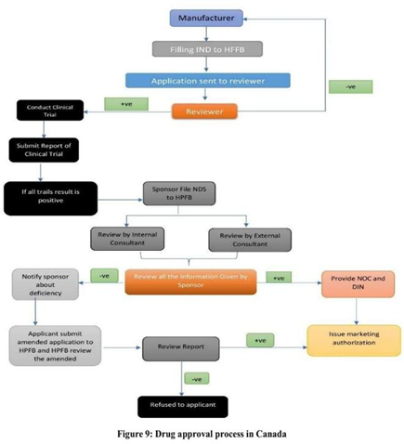
Figure: Drug approval process in Canada

In case the manufacturer fails to remain in compliance with the Food and Drug Act and the regulations, or when new information is discovered about safety, efficacy or quality concerns, the HPB reserves the right to suspend or revoke the NOC.

The integrity of the medication regulatory structure in Canada, as well as the assurance of the further protection of the health of the population, is supported by this comprehensive post-approval inspection.^{14,17}
Comparison chart of drug approval process in India, us, and canada:
Parameter | India | United States | Canada
Regulatory Authority | Central Drugs Standard Control Organization (CDSCO); Drugs Controller General of India (DCGI). | U.S. Food and Drug Administration (FDA). | Health Canada – Health Protection Branch (HPB) & Drugs Directorate (DD). ^{6,7}
Governing Law / Regulations | Drugs & Cosmetics Act 1940 and Rules 1945; Schedule Y (updated 2005). | Federal Food, Drug, and Cosmetic Act (FD&C Act). | Food and Drugs Act.^{6,18}
Pre-Clinical Requirements | Animal studies per Schedule Y; chemistry, manufacturing, toxicity data required before CTA. | Extensive preclinical studies (pharmacology, toxicology) needed before IND filing. | Preclinical animal/toxicology studies; preliminary information package to HPB prior to IND.^{8,9,18}
Application to Begin Clinical Trials | Clinical Trial Application (CTA) submitted to DCGI + Ethics Committee approval. | Investigational New Drug (IND) application. Required before any human trial. | Investigational New Drug (IND) but preceded by an information package reviewed by HPB. "Silent approval" if no objections.^{8,9,10,18}
Timeline for Clinical Trial Approval | Category A trials: fast-track within 2 months. Category B trials: 16–18 weeks. | FDA reviews IND within 30 days; if no clinical hold, trials may begin. | HPB uses silent approval mechanism; clinical trials can begin if no objections within review period.^{6,9,14,18}
Phases of Clinical Trials | Phase I–IV (as per global standard). Minimum sample sizes specified (e.g., 500+ in Phase III if not marketed elsewhere). | Standard Phase I–III before NDA; Phase IV post-marketing. | Standard global Phases I–IV. ^{5,9,14,18}
Application for Marketing Approval | New Drug Application via Form 44 with full preclinical, clinical, CMC, labeling data. | New Drug Application (NDA) containing full clinical, preclinical, CMC, statistical, and labeling data (≈100,000+ pages). | New Drug Submission (NDS) with complete safety, efficacy, and quality data. Reviewed by DD.^{6,10,12,14}
Outcome of Marketing Application | Approval by DCGI → drug enters Phase IV post-marketing surveillance. | FDA issues Approval, Approvable, or Not Approvable letters. | HPB issues Notice of Compliance (NOC); remains valid but subject to annual monitoring.^{10,12,14,17}
Post-Marketing Surveillance | Mandatory Phase IV studies; ongoing safety monitoring. | FDA requires post-marketing (Phase IV) commitments for safety. | Annual review; NOC can be suspended if concerns arise.^{7,11,17}
Unique Features | Dual authority (Central + State); fast-track for drugs approved in select countries. | One of the world’s most stringent and comprehensive drug approval systems. | Pre-IND information package; silent approval; no expiration on NOC.^{6,7,18}
CONCLUSION:
The process of drug approvals in India, the United States, and Canada have a similar basis that is founded on scientific consideration, regulatory control, and determination to protect the population health. Every nation has a systematic procedure where preclinical trials are done followed by gradual clinical trials, and finally review of safety, efficacy, and quality information is made and marketing authorization is given. Although India is governed by a dual system where both central and state governments assume control, the U.S and Canada depend on a single national body- the FDA and Health Canada respectively leading to a more centralized system of control. The U.S. system is commonly known to be very strict with the evidentiary standards, excessive documentation requirements, and thorough review of clinical outcomes. The Canadian system focuses on scientific review and the use of such mechanisms as a silent approval of clinical trials and post-market monitoring with the use of the Notice of Compliance. The regulatory regime in India has also improved with the revisions of Schedule Y, the introduction of expedited routes in drugs which are already approved in the developed countries, and the definition of the phases of clinical trials became clearer. The structural and procedural diversities notwithstanding, the three systems have a common objective of making sure that patients have access to safe and effective medicines of high quality. All these approval schemes represent the regulatory priorities and national-level philosophies of patient protection and ultimately, they all seem to be united by the common goal of safeguarding patients and allowing them to access innovative therapeutic products in a timely manner.
REFERENCE:
- Shah C, Dave P. Regulatory approval in India: an updated review. Applied Clinical Trials [Internet]. 2016 May 4. Available from:
http://www.appliedclinicaltrialsonline.com/regulatory-approval-india-updated-review
- Central Drugs Standard Control Organization (CDSCO). Guidance for industry on preparation of common technical document for import/manufacture and marketing approval of new drugs for human use (NDA) [Internet]. New Delhi: CDSCO; 2014 Jan [cited 2014 Jan]. Available from: http://cdsco.nic.in/CTD_Guidance%20Final.pdf
- U.S. Food and Drug Administration. About FDA [Internet]. Silver Spring (MD): FDA. Available from: https://www.fda.gov/about-fda
- Appel WC. Post marketing surveillance in Canada. Drug Information Journal. 1996;30(3):655–659.
- Pendharkar D, Padmanabhan NA. The drug approval process in India. ASCO Daily News [Internet]. 2016 May 26. Available from: https://am.asco.org/daily-news/drug-approval-process-india
- Patel J, Parikh K, Shah D. New drug approval procedure in India. Pharma tutor [Internet]. Available from: https://www.pharmatutor.org/articles/new-drug-approval-procedure-india
- Central Drugs Standard Control Organization (CDSCO), Ministry of Health and Family Welfare. Guidance for industry [Internet]. New Delhi: CDSCO; 2016 [cited 2016 Jan 7]. Available from: https://cdsco.nic.in/writereaddata/CDSCO_GuidanceForIndustry.pdf
- U.S. Food and Drug Administration. IND applications for clinical treatment: contents and format [Internet]. Silver Spring (MD): FDA. Available from: https://www.fda.gov/drugs/investigational-new-drug-ind-application/ind-applications-clinical-treatment-contents-and-format
- U.S. Food and Drug Administration. Investigational new drug (IND) application [Internet]. Silver Spring (MD): FDA. Available from: https://www.fda.gov/drugs/types-applications/investigational-new-drug-ind-application
- Centre for Drug Evaluation and Research (CDER). IND application process (interactive session) [Internet]. Silver Spring (MD): FDA; 2014 Jan [cited 2014 Jan]. Available from: https://www.fda.gov/cder/regulatory/applications/ind_page_1.htm
- U.S. Food and Drug Administration. About FDA [Internet]. Silver Spring (MD): FDA. Available from: https://www.fda.gov/about-fda
- Rawson NSB. The timeliness of new drug approvals in Canada. International Journal of Health Services. 1995;25(1):153–165.
- Rawson NSB, Kaitin KI, Thomas KE, Perry G. Drug review in Canada: a comparison with Australia, Sweden, the United Kingdom, and the United States. Drug Information Journal. 1998; 32:1133–1141.
- Rawson NSB. Time required for approval of new drugs in Canada, Australia, Sweden, the UK and the USA in 1996–1998. Canadian Medical Association Journal. 2000;162(4):501–504.
- Pacific Bridge Medical. India’s Central Drugs Standard Control Organization (CDSCO). Pacific Bridge Medical [Internet]. 2012 Dec 29 [cited 2012 Dec 29]. Available from: https://www.pacificbridgemedical.com
- Sinha K. India to open first drug inspection office in Beijing. Times of India [Internet]. 2012 [cited 2012 Dec 29]. Available from: https://timesofindia.indiatimes.com
- Comparison of the drug approval processes in the US, the EU and Canada. Journal of Medical Marketing. 2001 Feb. Available from:
https://www.researchgate.net/publication/244884791
- A review on drug approval process for USA, Europe and India. International Journal of Pharmaceutical Research and Applications. 2025;10(5):1001–1006. Available from: https://www.ijprajournal.com
- Government of Canada. Health Canada [Internet]. Available from: http://www.canada.ca [Last accessed on 2019 Jan].
- Shaik M, Nadendla RR, Santhipriya N, Koushik Y. Regulatory requirements and approval process of new drug in India and USA.
- Health Canada. Drug and health product submissions under the Food and Drugs Act [Internet]. Ottawa: Government of Canada; 2019. Available from: https://www.canada.ca/en/health-canada/services/drugs-health-products/drug-products/applications-submissions.html
- Health Canada. Notice of Compliance (NOC) [Internet]. Ottawa: Government of Canada; 2018. Available from: https://www.canada.ca/en/health-canada/services/drugs-health-products/drug-products/notice-compliance.html
- Gupta SK. Drug approval process and clinical trial regulations in Canada, USA and India. Journal of Pharmaceutical Sciences and Research. 2013;5(7):144–150.
- World Health Organization. Regulatory systems strengthening for medicines [Internet]. Geneva: WHO; 2017. Available from:
https://www.who.int/medicines/areas/quality_safety/regulation_legislation

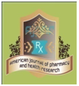
AJPHR is
- Peer-reviewed
- monthly
- Rapid publication
Submit your next manuscript at
editor@ajphr.com / editor.ajphr@gmail.com

