
Research Article
AMERICAN JOURNAL OF PHARMACY AND HEALTH RESEARCH
www.ajphr.com
2026, Volume 14, Issue 03
ISSN: 2321–3647(online)

A case of Pericardial Effusion in Patient with Hypertension and CKD Grade-V.

Nishant Kumar¹*, Anshu Kumari²
1.Medanta Hospital Gr.Noida
2.Icare Medical College Hospital, Haldia, West Bengal

ABSTRACT
The Pericardium is a membrane like structure which envelops the heart and the proximal great vessels from all around. In normal physiological conditions, there is ~ 10 – 50 ml of pericardial fluid present. But, significant accumulation of pericardial fluid can occur in certain conditions like inflammation or infection of the pericardium and adjacent surrounding structures. This condition can remain asymptomatic for significant time period and incidentally can be found after any imaging investigations for another disease process, or patient can present with shock like symptoms due to cardiac tamponade. Here, one point is of significant notification that it is the rate of accumulation of the fluid around pericardium, and not the absolute size of the heart, that primarily determines the symptoms that occur in the pericardial effusion. Meanwhile the clinical suspicion may be introduced by the history of the patient, examination of the patient, electrocardiogram investigation, or chest X-ray. In all these, the echocardiogram is the basic and mainstay to confirm the diagnosis. Options for treatment depends on the etiology and hemodynamics consequences of the heart. This article mainly focuses on the etiology, pathophysiology, investigation, chest X-Ray, CT, and management of the pericardial effusion.
Keywords: Pericardial effusion, Chest X-Ray, Moneybag appearance of Heart, Hypertension, CKD Grade V.

*Corresponding Author Email: nishant1810kumar@gmail.com
Received 10 January 2026, Accepted 20 February 2026

INTRODUCTION
A pericardial effusion is defined as a pathological condition in which there is accumulation of pericardial fluid within the pericardium. The pericardium refers to a membrane that surrounds the heart and proximal great vessels all around. In normal physiological conditions, there is ~ 10 – 50 ml of pericardial fluid present. But, significant accumulation of pericardial fluid can occur in certain conditions like inflammation or infection of the pericardium and adjacent surrounding structures. This can deteriorate the cardiac function by increasing the inter-pericardial pressures. The clinical presentation of the patient may vary; ranging from remaining asymptomatic when the discovery of pericardial effusion is established as an incidental finding, while others may present with cardiac tamponade in serious conditions like cardiogenic shock which requires interventional management as an urgent treatment requirement. Transthoracic echocardiogram (TTE) is the investigation of choice which remains the mainstay of diagnosis, but several emerging techniques, like Quantitative fluid analysis and Cardiac MRI , helps to improve the cardiac catheterization. Management options depends on the hemodynamics impact of the condition. Those which are stable effusions, justifies treatment of underlying causes, while cardiac tamponade requires urgent pericardiocentesis. Innovations include the pericardial window technique and intrapericardial therapy for those having malignant effusions. This review synthesizes contemporary evidence on the etiology, pathophysiology, investigations and innovative management of the pericardial effusion.
REVIEW OF PERICARDIUM
Anatomy and Physiology:
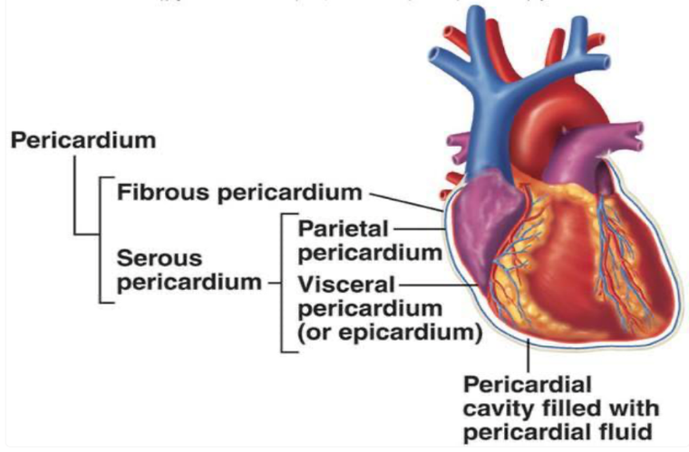
Figure 1: Anatomical demonstration of the pericardial layers and cavity. From superficial to deep: Fibrous pericardium ⇒ Parietal pericardium ⇒ Pericardial cavity ⇒Visceral pericardium.
The Pericardium is a membrane like structure which is situated in the middle mediastinum of the thorax, which completely envelops the heart and the proximal great vessels. The anatomy and functions of pericardial fluid are summarized in Figure 1 and Table 1.
The pericardium is composed of two layers.
(1) Outer Fibrous layer:
- Made up of non-elastic connective tissue.
- Produces reflecting image on TTE.
- Is crucial layer in protecting the heart from over-expansion, e.g. in an aneurysm.
- But because of its inflexibility nature, more production of pericardial fluid leads to increase intrapericardial pressure, which leads to development of cardiac tamponade.
(2) Inner Serous layer:
- Composed of parietal and visceral layers.
- Parietal layers surrounds the inner surface of fibrous layer, while visceral layer remains in direct contact with the surface of the heart. The visceral layer, which is also called as epicardium, is the site which is mainly responsible for production of pericardial fluid. The significant space between these two layers is the site where pericardial fluid resides, which is less than 10-50 ml in volume under normal physiology condition. This pericardial fluid acts as a lubricant, allowing the frictionless and smooth less movement of the heart muscles within the mediastinum.
Table 1: Functions of the pericardium and pericardial fluid.
1) | Restricts the overdistension of the four cardiac chambers.
2) | Facilitates the ventricular interaction and interdependence.
3) | Promotes coupling of atria and ventricles.
4) | Equalizes physical forces across the myocardium.
5) | Minimizes the friction with surrounding structures.
6) | Acts as a barrier from restricting the spread of infection.
Etiology Of Pericardial Effusion: -
Idiopathic | Unknown causes
Infections | Bacteria: Borrelia burgdorferi, Chlamydia, H. influenzae, Legionella, Mycoplasma, M. tuberculosis, Neiserria, Pneumococci, Stahylococci, Streptococci, Salmonella.  Viruses: Adenovirus, Coxsackievirus, Cytomegalovirus, Epstein-Barr virus, HIV, Influenza virus, Measals-Mumps-Rubella, Parvovirus B19.  Fungi : Aspergillus, Candida sp., Histoplasma.  Parasites : Entamoeba hystolytica, Toxoplama gondii.
Neoplasm | Primary : Angioma, Fibroma, Lipoma, Rhabdomyosarcoma and Teratoma.  Secondary : Lung or Breast carcinoma, Lymphoma and Leukemia.
Myocardial Infarction | Ventricular aneurysm rupture
Drugs | Cyclosporine, Heparin, Isoniazid, Hydralazine, Minoxidil and Warfarin
Autoimmune Diseases | Inflammatory bowel diseases, Mixed connective tissue disorder, Myasthenia gravis, Polyarteritis nodosa, Rheumatoid arthritis, SLE, Scleroderma, Temporal arteritis and Sarcoidosis.
Trauma | Blunt, Penetrating or Iatrogenic, e.g. Perforation caused by catheter insertion, Pacemaker implantation or cardiac surgery.
Others | Amyloidosis, Aortic dissection, Hypothyroidism, Pericardial injury syndrome, Radiation and Uremia.
PATHOPHYSIOLOGY OF PERICARDIAL EFFUSION:
Accumulation of fluid in pericardium occurs due to three main reasons:
- Decrease in absorption.
- Increase in production.
- Any hemorrhage from cardiac injury.
In all these above-mentioned conditions, pericardial effusion can occur if the rate of production exceed the rate of drainage. The accumulation of fluid usually owes to inflammation / infection of the pericardium with / without accompanying adjacent structures. Pericardial fluid mainly comprises of plasma ultrafiltrate, and the production mainly depends on the interplay of the hydrostatic and osmotic pressures.
Term | Definition | Description
Serous | Straw-colored fluid | Pale, Yellow, and Transparent
Sanginous | Fresh, Frank blood | Thick and Red
Serosanginous | Blood-stained fluid | Thin, Pink and Watery
Purulent | Pus | Thick and Grey, Green, or Yellow.
Increase in hydrostatic pressure:
Conditions which causes increase in hydrostatic pressure, includes Heart failure, or decrease in osmotic pressure, which includes Liver cirrhosis, which leads to increase in pericardial fluid quantity due to decrease in absorption, which results in accumulation of transudate. In addition, lymphatic system damage can disturb the balance between production and damage of pericardial fluid, which finally results in accumulation of pericardial fluid.
Increase in production:
Conditions which cause inflammation of pericardium, includes Pericarditis, Increase vascular permeability and results in accumulation of exudate due to increased production of pericardial fluid.
Hemorrhage:
In case of Cardiac Trauma, hemopericardium is a rapid accumulation of blood and blood products in the pericardial space which can occur due to heart or proximal great vessels
perforation.
Term | Definition | Common cause
Pneumopericardium | Accumulation of air in the pericardial space | Gas producing organisms
Haemopericardium | Accumulation of blood in the pericardial space | Trauma or iatrogenic
Chylopericardium | Accumulation of lymph/pus in the pericardial space | Injury to thoracic duct
In acute pericardial effusion, the first chamber which is affected is Right Atrium, because of its low pressure as compared to other chambers. This results in reduction of cardiac filling during diastole, which is an emergency situation. Cardiac filling is determined by transmural pressure, which is difference between intracardiac and pericardial pressure. When there is a progressive increment in fluid, it results in atrial and ventricles compression, which further decreases stroke volume and consequently, the cardiac output. This results in adrenergic stimulation, which causes increase in heart rate via beta-adrenergic receptors to increase cardiac output, which is defined as the product of stroke volume and heart rate. Adrenergic stimulation via alpha receptors causes increase in systemic and pulmonary venous pressure, which leads to increase the blood volume. These compensatory mechanism try to support the heart until a definitive treatment is planned. But, if it does not seems to occur, then the heart may go into severe compromised state and proceed to go into florid tamponade state. Patient who are not able to sustain an adrenergic response, where there is beta-blockage, may be more susceptible to develop cardiac tamponade.
Classification of pericardial effusion:
Category | Description | Definition
Onset | Acute  Chronic | < 3 months  > 3 months
Depth/Size | Mild moderate large | < 10 mm, 10-20 mm, > 20 mm
Distribution | Localized global | Adjacent to >/= 1 cardiac chamber, adjacent to all 4 cardiac chambers.
Composition | Exudate transudate | Protein > 30 g/l, Protein < 30 g/l
Factors influencing the magnitude of hemodynamically abnormalities:
 | Increase | Decrease
Rate of pericardial fluid accumulation | Rapid, e.g. Minutes - Hours | Slow, e.g. Weeks - Months
Pericardial compliance | Stiff, e.g. Constrictive pericarditis | Pliable, e.g. Normal pericardium
Intracardiac filling pressures | Low, e.g. Normal health | High, e.g. LVH/LV systolic dysfunction/HTN/AS/HF with preserved EF or RVH/RV Systolic dysfunction/PS/PAH
Intracardiac compliance | Low, e.g. Normal myocardium | High, e.g. LVH or RVH.
CASE REPORT:
A patient came to emergency department with complains of breathlessness. Patient vitals checked, ABG done, and all blood investigations were done and sent to laboratory. Urine samples taken and sent for investigation. Patient was a known case of Hypertension and CKD – Grade V, and was on Medical Hemodialysis since October 2024. He was also having history of ATT treatment since November 2025. Stat treatment was given in form of Inj. Pantoprazole 40 mg i.v. stat followed by infusion at 8 mg/hour, Inj. Emeset 4 mg i.v. stat, Inj. Lobet @ 10 mg /hour, Inj. Lasix 40 mg i.v. stat., Inj. Calcium Gluconate 10% 10 ml i.v. stat, Inj. 25% Dextrose + 8 Units Regular Insulin i.v. stat, Nebuliser with Salbutamol NIV Bipap FiO2- 40% PEEP-6 PS-12.
After all samples taken and sent from ER department, the patient shifted to ICU with oxygen support with flow rate of 10 liters/hr. Recently, he was diagnosed with Tubercular pleural effusion for which he was on Anti-tubercular treatment since January 2026 with complains of breathlessness at rest, blood mixed vomiting 2-3 episodes since morning. There was history of dry cough also since 2-3 days. Mild chest discomfort was also present on the left side. There was no any complains of fever, syncope, abdominal pain, loose stools, melena, constipation.
On examination, airway was patent, RR was 23 beats/min, SPO2 (% on RA) was 92, SPO2 (% on O2) was 100, Eye and ENT examination Pallor and Icterus was present, Chest examination Bilateral air entry was present, crepts was present, and air entry was reduced on the left side, CVS examination was normal with S1S2 heard and no murmur present, Per Abdomen examination was soft, mild diffuse tenderness present, on Extremity examination Right side subclavian permanent catheter seen insitu, CNS examination was normal and patient was conscious and oriented to time, place and person. There was no any history of any known allergy. He was currently on Tab. Benadon 40, Tab. Moxifloxacin 400 mg, and Tab. Ethambutol, Tab. Pyrazinamide 750 mg.
There was past history of Hypertension and CKD grade V and on maintenance hemodialysis since October 2024. Recently, he was diagnosed with Tubercular pleural effusion for which he was on Anti-tubercular treatment since January 2026. Provisional diagnosis of CKD grade V and on maintenance hemodialysis, since October 2024, Hypertension, recently diagnosed with tubercular pleural effusion and was started Anti-Tubercular Treatment in January 2026 with volume overload, hyperkalemia, Upper GI Bleed under evaluation was made.
ECG, Blood investigations, Radiological investigations like Chest X-Ray and USG Whole abdomen was advised. Chest X-Ray PA view findings report showed blunting of bilateral costophrenic angles (R>L), Cardiac silhouette enlargement and globular shaped which suggests Pericardial effusion, and rest all findings were unremarkable.
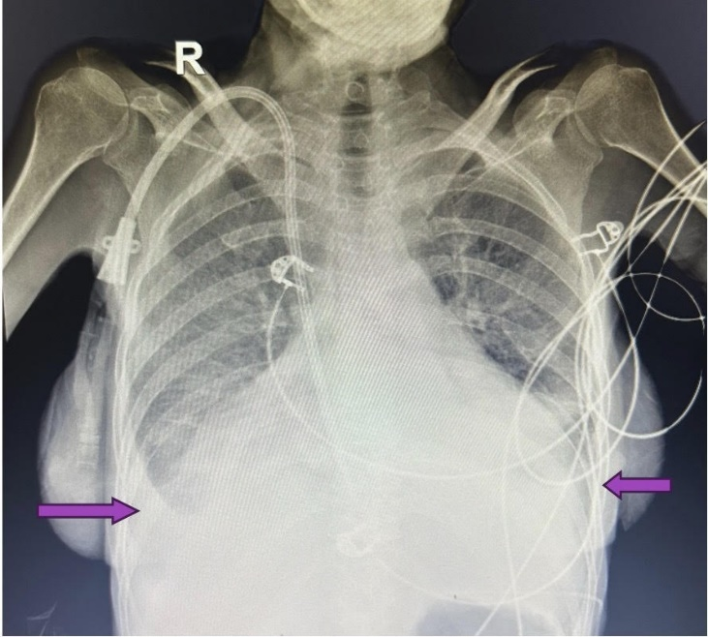
Figure 1 : Chest X-Ray PA view : Blunting of bilateral costophrenic angles (R>L) (violet arrowhead), Cardiac silhouette enlargement and globular shaped which suggests Pericardial effusion.
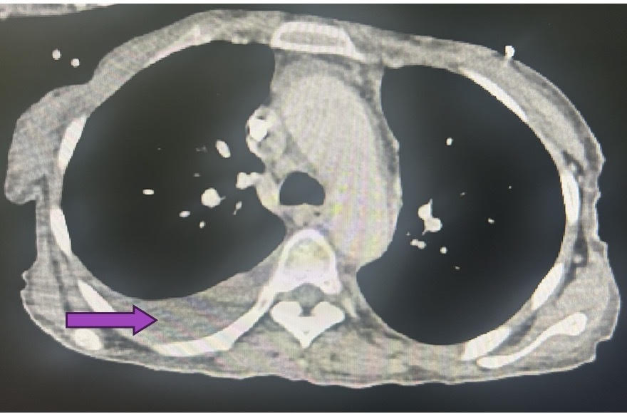
Figure 2: Axial Computed Tomography Chest image showing mild to moderate Pleural effusion on right side (violet arrowhead).
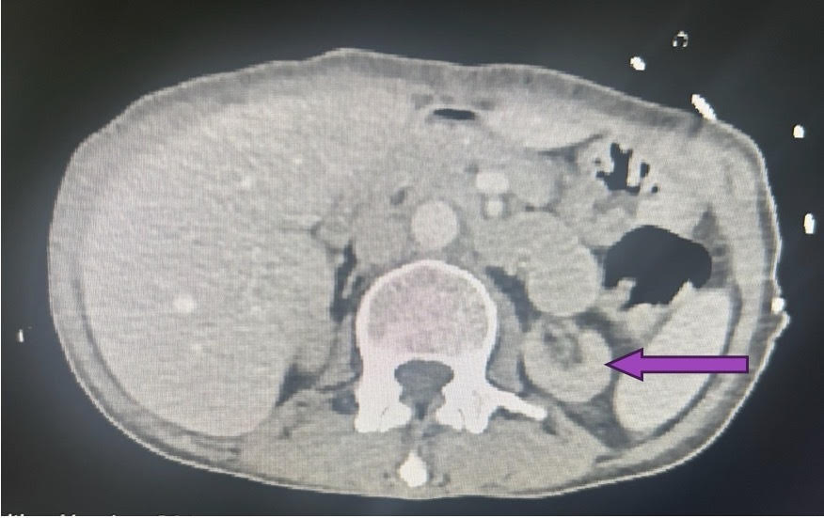
Figure 3 : Area of consolidation with collapse in lateral segment of right middle lobe (right violet arrowhead) and minimal pleural effusion on left side with underlying left lower lobe collapse/consolidation (left violet arrowhead).
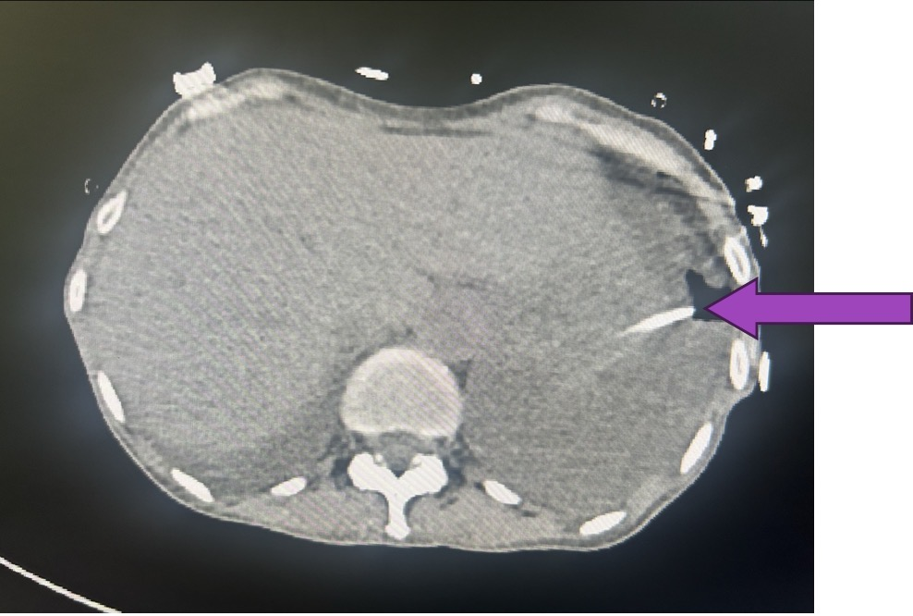
Figure 4: Left sided ICD tube insitu.
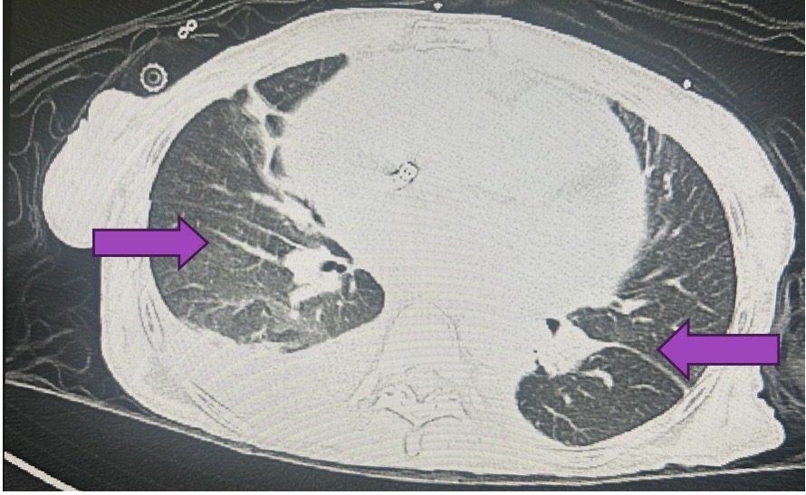
Figure 5 : Fibroatelectatic bands in bilateral lung fields.
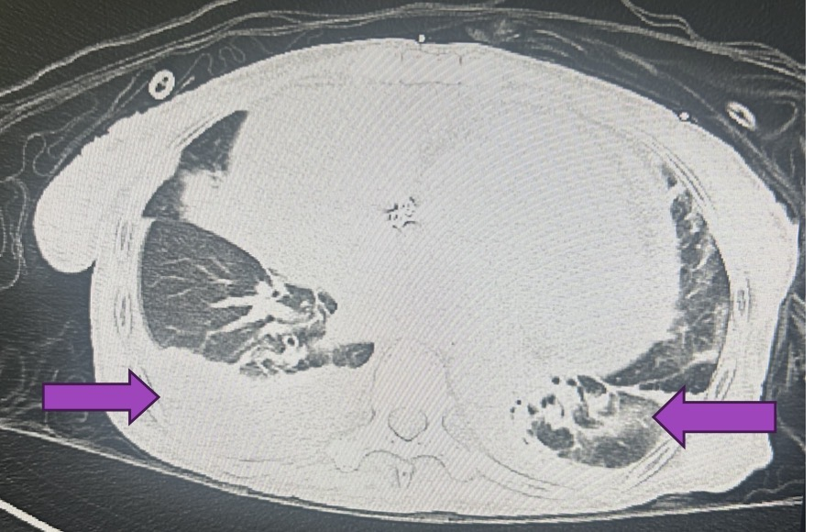
Figure 6 : Axial Computed Tomography Chest image showing mild pleural effusion with underlying right lower lobe collapse/consolidation and minimal pleural effusion with underlying left lower lobe collapse/consolidation (violet arrowhead).
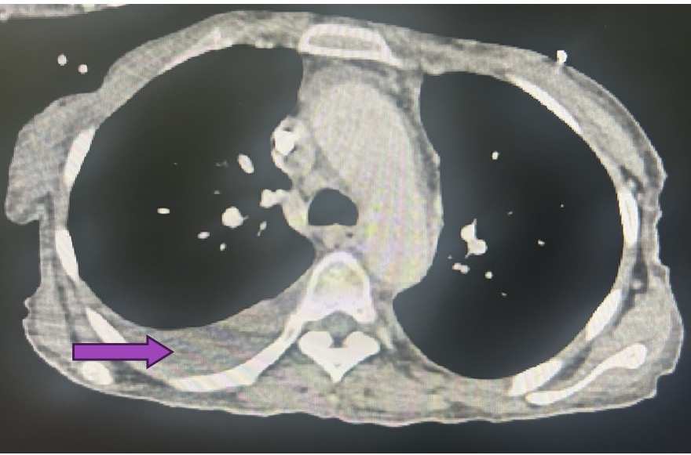
Figure 7 : Axial Computed Tomography Chest image showing mild to moderate Pleural effusion on right side (violet arrowhead).
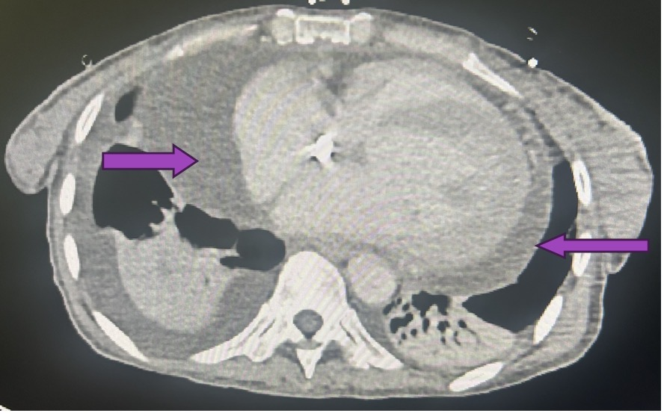
Figure 8 : Axial Computed Tomography Chest image showing mild to moderate pericardial effusion (violet arrowhead).
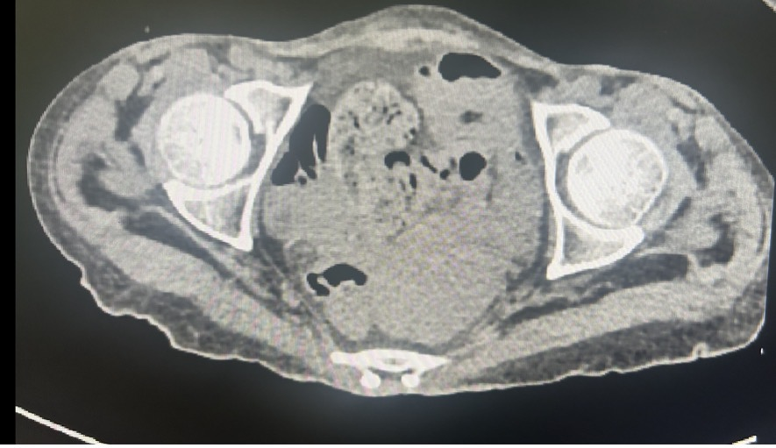
Figure 9 :Mild free fluid in the pelvis.
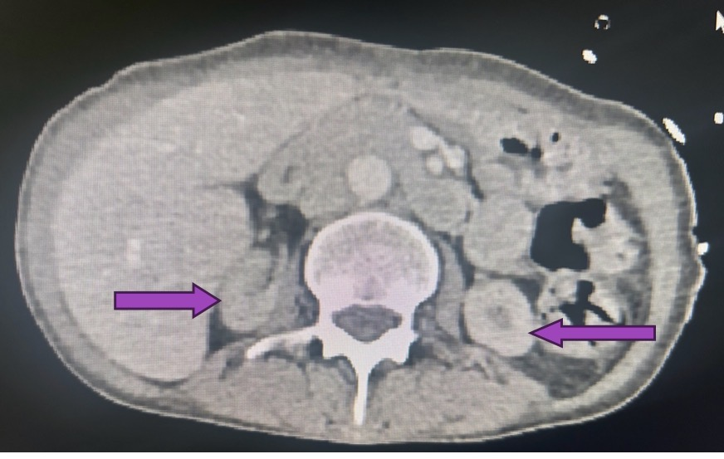
Figure 10 : Axial Computed Tomography Pelvis image showing reduction of size in both kidneys with mild reduction of cortical thinning (violet arrowhead).

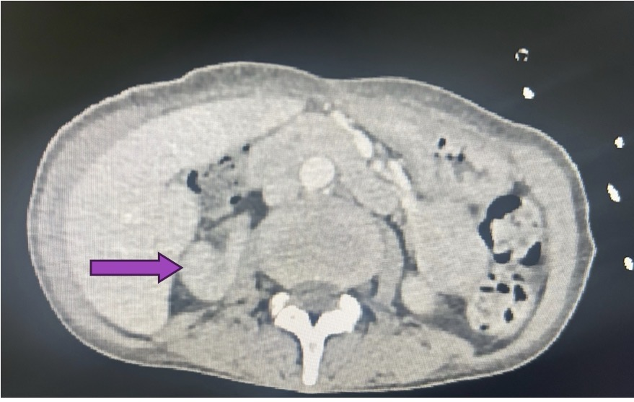
Figure 11: Axial Computed Tomography Pelvis image showing reduction of size in right kidney with mild reduction of cortical thinning (violet arrowhead).
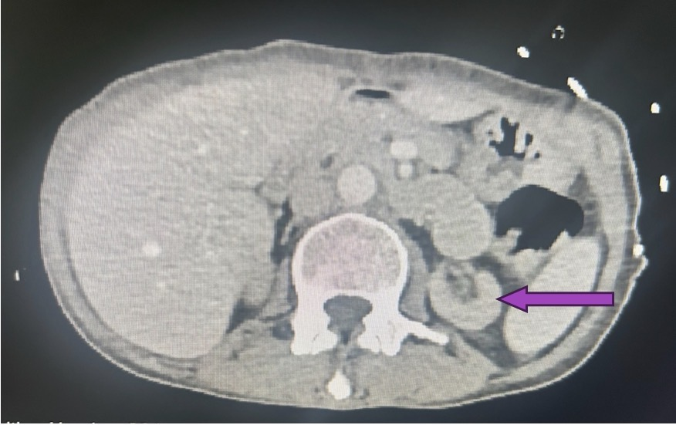
Figure 12 : Axial Computed Tomography Pelvis image showing reduction of size in left kidney with mild reduction of cortical thinning (violet arrowhead).
The final diagnosis of pericardial effusion with hypertension and chronic kidney disease grade V with bilateral pleural effusion (R>L) and underlying bilateral lobe collapse/consolidation was made.

Primary Survey:
Airway Assessment | Patent
Respiratory Rate (RR) | 23
Laboured | Yes
SPO2 (% on RA) | 92
SPO2 (% on O2) | 100
Head, Eye and ENT | Pallor + , Icterus +
Chest | B/L air entry +, Crepts +, Air entry reduced on left side.
CVS | S1 S2 heard, No murmur
Per Abdomen | Soft, Mild diffuse tenderness +
Extremity | Right Subclavian permanent catheter insitu
CNS | Conscious and well oriented to time, place and person
Allergies | Not known
Medications | Tab. Benadon 40, Tab. Moxifloxacin 400 mg, and Tab. Ethambutol, Tab. Pyrazinamide 750 mg
Past history | CKD grade V and on maintenance hemodialysis, since October 2024, Hypertension, recently diagnosed with tubercular pleural effusion and was started Anti-Tubercular Treatment in January 2026 with volume overload, hyperkalemia, Upper GI Bleed under evaluation.
Last meal | 2:00 pm
Events prior to the incident | Patient develop these symptoms since today morning.
Working Diagnosis | CKD grade V and on maintenance hemodialysis, since October 2024, Hypertension, recently diagnosed with tubercular pleural effusion and was started Anti-Tubercular Treatment in January 2026 with volume overload, hyperkalemia, Upper GI Bleed under evaluation.
Investigations :
 | ECG
Blood | ABG, CBC, LFT, RFT, CRP, Blood Culture and Sensitivity, High sensitivity Cardiac Troponin I, N-terminal pro-B-type natriuretic peptide(NT-pro-BNP), Creatine-Kinase (CK-MB) tests
X-Rays | Chest X Ray PA view
USG | USG Whole abdomen
After all these, the patient was refferred to Nephrology and Gastroenetrology departments. The reason for referral in Gastroenetrology department was Upper GI Bleed and in Nephrology department was CKD grade V and on maintenance hemodialysis, since October 2024, Hypertension, recently diagnosed with tubercular pleural effusion and was started Anti-Tubercular Treatment in January 2026 with volume overload, hyperkalemia.
Patient Vitals:
Temperature (Farenheit) | 98.5
Pulse | 132
Respiratory Rate (breaths/min) | 24
Systolic BP | 190
Diastolic BP | 110
Saturated partial pressure of Oxygen (SpO2) | 96
Record | BMI
Height (cm) | 157
Weight (kg) | 48
BMI (kg/m2) | 19.47
Supplement O2 | Yes
Eyes open | Spontaneously
Verbal response | Oriented
Motor response | Obeys commands
GCS Score | 15
Pain assessment score | 2
MEWS Score | 7
Secondary Survey :
Head, Eye and ENT | Pallor + , Icterus +
Chest | B/L air entry +, Crepts +, Air entry reduced on left side.
CVS | S1 S2 heard, No murmur
Per Abdomen | Soft, Mild diffuse tenderness +
Extremity | Right Subclavian permanent catheter insitu
CNS | Conscious and well oriented to time, place and person
Allergies | Not known
Medications | Tab. Benadon 40, Tab. Moxifloxacin 400 mg, and Tab. Ethambutol, Tab. Pyrazinamide 750 mg
Past history | CKD grade V and on maintenance hemodialysis, since October 2024, Hypertension, recently diagnosed with tubercular pleural effusion and was started Anti-Tubercular Treatment in January 2026 with volume overload, hyperkalemia, Upper GI Bleed under evaluation.
Last meal | 2:00 pm
Events prior to the incident | Patient develop these symptoms since today morning.
Working Diagnosis | CKD grade V and on maintenance hemodialysis, since October 2024, Hypertension, recently diagnosed with tubercular pleural effusion and was started Anti-Tubercular Treatment in January 2026 with volume overload, hyperkalemia, Upper GI Bleed under evaluation.
Investigations :
Point Of Care (POC) Test | ECG
Blood | ABG, CBC, LFT, RFT, CRP, Blood Culture and Sensitivity, High sensitivity Cardiac Troponin I, N-terminal pro-B-type natriuretic peptide(NT-pro-BNP), Creatine-Kinase (CK-MB) tests
X-Rays | Chest X Ray PA view
USG | USG Whole abdomen
Lab. Investigations :
Creatinine Phosphokinase | 26 U/L (30-136 U/L)
HS Troponin I | 34.95 ng/L (0-9 ng/L)
Total Bilirubin | 0.70 mg/dl (0.20 – 1.30 mg/dl)
Direct Bilirubin | 0.70 mg/dl (0.00 – 0.30 mg/dl)
Total Protein | 6.90 g/dl (6.30 – 8.20 g/dl)
Albumin | 3.80 g/dl (3.50 – 5.0 g/dl)
Globulin | 3.10 g/dl (2.40 – 3.50 g/dl)
A/G Ratio | 1.2 (0.9 – 2.0)
SGOT (AST) | 1.5 U/L (14-36 U/L)
SGPT (ALT) | < 4 U/L (0-35 U/L)
Gamma GT | 94 U/L (12-43 U/L)
Alkaline Phosphatase (ALP) | 111 U/L (30-120 U/L)
NT Pro-BNP | 89400 pg/ml (0-125 pg/ml)
Blood Urea | 149 mg/dl (15-36 mg/dl)
Serum Creatinine | 7.0 mg/dl (0.70 – 1.20 mg/dl)
Serum Uric Acid | 5.3 mg/dl (2.5 – 6.2 g/dl)
Serum Sodium | 137 mmol/L (137 – 145 mmol/L)
Serum Potassium | 6.3 mmol/L (3.5 – 5.1 mmol/L)
Serum Calcium | 9.6 mmol/L (8.4 – 10.2 mmol/L)
Serum Chloride | 96 mmol/L (98 – 107 mmol/L)
APTT | 24.5 sec (22.2 – 33.1 sec)
Hemoglobin | 7.3 g/dl (12 – 15 g/dl)
RBC Count | 2.42 million/cu.mm (3.8 -4.8 million/cu.mm)
Hematocrit | 23.0 % (36 -46 %)
MCV | 95.1 fl (83 -101 fl)
MCH | 30.2 pg (27 -32 pg)
MCHC | 31.7 g/dl (31.5 – 34.5 g/dl)
RDW | 15.60 % (11.60 – 14.00 %)
Platelet Count | 269 10^3/μL (150 -410 10^3/μL)
MPV | 10.1 fl (8.6 -15.5 fl)
WBC | 11.12 10^3/μL (4-10 10^3/μL)
Neutrophil | 94.6 % (40 - 80 %)
Lymphocyte | 2.8 % (20 - 40 %)
Monocyte | 2.2 % (2.0 – 10.0 %)
Eosinophil | 0.3 % (1.0 – 6.0 %)
Basophil | 0.1 % (0.0 – 2.0 %)
Absolute Neutrophil Count | 10.53 10^3/μL (2 – 7 10^3/μL)
Absolute Lymphocyte Count | 0.31 10^3/μL (1 – 3 10^3/μL)
Absolute Monocyte Count | 0.24 10^3/μL (0.20 – 1.0 10^3/μL)
Absolute Eosinophil Count | 0.03 10^3/μL (0.02 – 0.50 10^3/μL)
Absolute Basophil Count | 0.01 10^3/μL (0.02 – 0.10 10^3/μL)
PT | 10.6 sec (9 – 11.6 sec)
INR | 1.03 (< 0 - > 3.5)
URINE ANALYSIS :
Colour | Dark Yellow
Volume (ml) | 25 ml
Appearance | Turbid
pH | 8.0 (Normal) [Normal Range : 4.50 – 7.50]
Specific Gravity | 1.015 (Normal) [Normal Range : 1.005 – 1.035]
Protein | + 4
Glucose | Absent
Ketone Bodies | Negative
Nitrite | Negative
Bilirubin | Negative
Erythrocytes | + 3
Leukocyte Esterase | Negative
Urobilinogen | Normal
Pus Cells | 5.0/HPF (Normal) [Normal Range : 0.0 – 8.0/HPF]
Epithelial Cells | 1.0/HPF (Normal) [Normal Range : 0.0 – 5.0/HPF]
RBCs | 45.0/HPF (Increased) [Normal Range : 0.0 – 3.0/HPF]
Casts | Nil
Crystals | Nil
Prelim Report After Overnight Incubation | No Micro-organisms grown after overnight
DISCUSSION
The main bronchus on the left side in adult populations is approximately two times as long as the right and is more horizontally placed between the left pulmonary trunk anteriorly, descending thoracic aorta posteriorly, aortic arch superiorly, and the left pulmonary veins and left atrial appendage inferiorly. Due to its locationn in the mediastinum, it is highly susceptible to compressed by surrounding structures. Lung collapse can result from two ways like external compression or intrinsic obstruction of the bronchus. But, in adults the lung collapse from extrinsic compression of the bronchus from an enlarging pericardial effusion is rare entity. This is because, in normal adults, the bronchi have a tough cartilagenous framework and due to this it is resistant to compression, which is absent in children. A partial or complete collapse of the bronchus, can signify an underlying defect in the bronchial cartilage or prolonged exposure to increase pressure from the developing surrounding pericardial effusion. The pericardial disease is also associated with pleural effusion.
CONCLUSION :
Development of lung collapse in pericardial effusion is a rare occurrence in adults. It is suspected in patients when there is large pericardial effusions with acute hypoxic respiratory failure and there is no any other signs and symptoms of cardiac tamponade. Physicians should be aware about this rare presentation as these conditions are generally reversible with pericardial drainage. The most important role of clinicians is to identify the defiinitive etiology of the effusions, assess for clinical evidence of hemodynamic instability and then consider the appropriate management. The causes of a pericardial effusion are numerous, so, careful history taking is required to know the exact probablr causes. Lastly, long-term surviellance with serial TTE imaging assessment along with clinical surviellance enables early detection of progression and guides prompt management.
REFERENCES
- Yamani N, Abbasi A, Almas T, Mookadam F, Unzek S: Diagnosis, treatment, and management of pericardial effusion- review. Ann Med Surg (Lond). 2022, 80:104142. 10.1016/j.amsu.2022.104142
- Imazio M, Adler Y: Management of pericardial effusion. Eur Heart J. 2013, 34:1186-97
- Vakamudi S, Ho N, Cremer PC: Pericardial ellusions: causes, diagnosis, and management. Prog Cardiovaso DIS. 2017, 59:380-8. 10.1016/l-pcad.2016.12.009
- Lambert A. Salleron i. Kietter A. Ravmond P. Geottrois . Gavolle C• Intrapericardial instillation of bleomycin prevents recurrence of malignant pericardial effusions: series of 46 cases and comprehensive lterature review. sun Cancer, zuzu, lu/.Iso-bz. IU.101b/.bulcan.zUzU.04.U1U
- koonuez ek. lan to. structure and anatomy of the numan pericardium, Proe Cardiovasc Dis. zu17. 27.21- LU.1ULO/.3C44.=U1O.L.U1
- Pal ko. echocardiograony. A case studies-based approach. Jones & baruelt Learning, buruneton (MA):2U13.
- Lazaros G, Imazio M, Tsioufis P, Lazarou E, Vlachopoulos C, Tsioufis C: Chronic pericardial effusion: causes and management. Can | Cardiol. 2023, 39:1121-31. 10.1016/j.cjca.2023.02.003|
- Orihuela-Rodriguez O, Carmona-Ruiz H: Prevalence of pericardial effusion in systemic diseases. Gac Med Mex. 2019. 155:2018. 10.24875/GMM.M19000267
- Lazarou E, Vlachopoulos C, Antonopoulos A, Imazio M, Brucato A, Tsioutis C, Lazaros G: Asymptomatio chronic large pericardial effusions: to drain or to observe?. | Clin Med. 2024, 13:3887. 10.3390/jcm1313388|
- Ebrahimi P. Taheri H. Bahiraie P. et al: Incidence of secondary pericardial effusions associated with different etiologies: a comprehensive review of literature. | Cardiothorac Surg. 2025, 20:141. 1U.1186/S13019-025-035、0-5
- Dybowska M, Blasińska K, Gątarek ], Klatt M, Augustynowicz-Kopeć E, Tomkowski W, Szturmowicz M:
- Tuberculous pericardits-own experences and recent recommendations. Diagnostics (Basel). ZUzz, 12.019
- Aten K. Kanev K. Alomar A. Dressier svnarome: not lust a renc of the past, Cureus, ZUzz. 14.5Ub/U10.7759/cureus.30670
- Vats HS: Dysphagia from extrinsic compression of esophagus by pericardial effusion . Clin Med Res. 2008.


AJPHR is
- Peer-reviewed
- monthly
- Rapid publication
Submit your next manuscript at
editor@ajphr.com / editor.ajphr@gmail.com

