
Research Article
AMERICAN JOURNAL OF PHARMACY AND HEALTH RESEARCH
www.ajphr.com
2026, Volume 14, Issue 03
ISSN: 2321–3647(online)

A rare case of Antenatal Diagnosis of Dandy-Walker Malformation with association of Cleft lip/Cleft palate; posterior spinal defect with myelomeningocele, Colpocephaly; and other congenital defects at 21 weeks of gestation.

Nishant Kumar¹*, Anshu Kumari²
1.Medanta Hospital Gr.Noida
2.Icare Medical College Hospital, Haldia, West Bengal

ABSTRACT
Dandy-Walker Malformation is characterized by triad of Hypoplasia of vermis, Fourth ventricular cystic dilatation and tentorium cerebelli elevation. It is a rare anomaly of cerebellum which is commonly associated with other chromosomal disorder like Trisomy 13. The ultrasound is very critical and diagnostic imaging modality for diagnosis during antenatal period. We report a case of Dandy-Walker malformation with association of Cleft lip/Cleft palate; posterior spinal defect with myelomeningocele, colpocephaly; and other congenital defects that was diagnosed during a first routine prenatal ultrasound at 21 weeks of gestation.
Keywords: Dandy-Walker Malformation, Antenatal ultrasonography, Posterior fossa, Cyst herniation, Occipital meningoencephalocele, Posterior spinal defect with myelomeningocele, Cleft lip/palate

*Corresponding Author Email: nishant1810kumar@gmail.com
Received 10 January 2026, Accepted 13 February 2026

INTRODUCTION
In 1914, Blackfan and Dandy described some alterations of the posterior fossa as:
- Cystic dilatation of the 4th ventricle.
- Hypoplasia of the cerebellar vermis.
- Separation of the cerebellar hemispheres.
- Dilatation of the mesencephalic aqueduct, and
- Absence of the mediate and lateral apertures of the 4th ventricle.
These abnormalities were referred to as Dandy – Walker malformation. In the 1970s and 80s, different definitions were introduced for similar abnormalities of posterior fossa and then the classic definition of the Dandy-Walker
malformation originated.
Dandy-Walker Malformation is a rare complex congenital anomaly or syndrome which involves posterior fossa and cerebellum. It occurs in ~ 1/30000 to 1/35000 of live births. The “classical triad” of Dandy-Walker Malformation is defined by: Complete or partial agenesis of the vermis, enlargement of the posterior fossa with the upward displacement of the tentorium, transverse sinus and trocular; and cystic dilatation of fourth ventricle.
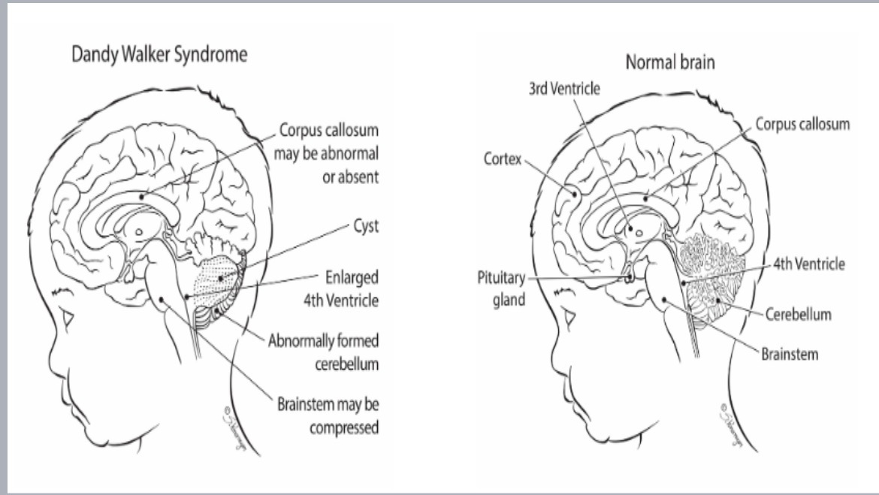
Figure 1: Difference between DANDY-WALKER SYNDROME BRAIN and NORMAL BRAIN.
What Is the Difference Between Dandy-Walker Complex and Dandy-Walker Syndrome?
- DANDY-WALKER COMPLEX is a group of disorders with similar symptoms. Dandy-Walker syndrome is one of the disorders included in Dandy-Walker complex.
- Other disorders included in Dandy-Walker complex are :
- Isolated cerebellar vermis hypoplasia or Dandy-Walker variant: The cerebellar vermis is small or underdeveloped. Children’s brains don’t have other structural issues associated Dandy-Walker syndrome. Many children with this diagnosis develop normally.
- Mega cisterna magna: The posterior fossa is large, but the cerebellum is typical. Mega cisterna magna often doesn’t cause any health issues.
- Posterior fossa Arachnoid cyst: A cyst develops on the posterior fossa. It’s not common for children to have symptoms due to the presence of a cyst.
Hydrocephaly is a common finding in Dandy-Walker Malformation which is seen in ~ 80% of the cases. Dandy-Walker Malformation is seen in ~ 4% - 12% of the cases of hydrocephaly in infants.
Pathogenesis:
The pathogenesis of Dandy-Walker Malformation lies in the feature that there is complicated developmental anomaly of the cerebellar vermis, which causes the failure of closure of the 4th ventricle. The failure of closure of the 4th ventricle results in persistent formation of Blake’s pouch. Subsequently, Blake’s pouch causes 4th ventricular enlargement, displacing cerebellar vermis in upward direction. As this cerebellar vermis displaces in upward direction, the development of tentorium, straight sinus, and torcula got arrested which results in posterior fossa enlargement.
Complicated developmental anomaly of cerebellar vermis

Failure of closure of the 4th ventricle

Persistent formation of Blake’s pouch

Enlargement of 4th ventricle, displacing the cerebellar vermis upwards.

Development of tentorium, straight sinus, and torcula is arrested.

Posterior fossa enlargement.

The Dandy-Walker malformation is frequently associated with other intracranial abnormalities such as occipital meningoencephalocele, and cleft lip/palate found in our case. Also, to be looked for: Agenesis of the corpus callosum, Holoprosencephaly and Ocular anomalies. Extra-cranial anomalies are also to be sought and are in order of frequency: Cardiac anomalies (38%), Facial dysmorphisms and cleft palate (26%), Dysgraphia, Poly- and Syndactyly (28%), Genital malformations – Urinary (28%) and Digestive (7%).
Other less common abnormalities include limb abnormalities, abdominal wall abnormalities and diaphragmatic hernia which are extremely rare and are not found in our clinical case.
Post natal studies indicate that the incidence of associated malformations is between 50% and 70%. The most common etiology is genetic.
Environmental factors, infections, including viral (CMV, Rubella), alcohol, and diabetes also seem to play a role in the pathogenesis of Dandy-Walker malformation but the scientific evidence remains uncertain. In our patient, there does not seem to be any infectious, environmental pr genetic factors, especially since the karyotype is normal. In the absence of an obvious cause, the risk of recurrence in subsequent pregnancies is 1% to 5%.
Prenatal ultrasound diagnosis of Dandy-Walker malformation is quite simple. However, it is important to differentiate with the other posterior fossa anomalies such as mega cisterna magna, and retrocerebellar arachnoid cyst. For this, a set of ultrasound signs must be look around for :
At the level of Posterior Cerebellar Fossa (PCF)
- In the cavo-thalamo-cerebellar section: A cystic dilatation of the V4 leading to widening of the FCP, anechoeic, triangular with an external base, the cerebellar hemispheres, hypoechogenic, and pushed back laterally and anteriorly, more or less hypotrophic, symmetrically or not. The vermis, echogenic, is hypotrophic or even absent (25%).
- In the sagittal section : The tentorium cerebelli is elevated; the vermis presents a more or less significant amputation of its lower part going as far as the complete absence of individualization. The lower part of the vermis can be extended toward the trocular by a linear image “in the tail of a comet” corresponding embryologically to the upper wall of the Blake pouch. The brainstem is normal.
On the supratentorial level
- Anomalies are found in 70% of cases. Hydrocephalus (60%), agenesis of the corpus callosum (15%), migration anomalies, lipomas and interhemispheric cysts, encephalocele, holoprosencephaly.
- As for the MRI, it finds its place especially in case of diagnostic doubt with the other cystic malformations of the posterior fossa or if there is strong presumption of a form close resemblance to the Dandy-Walker malformation with vermian hypoplasia formerly known as “Dandy-Walker variant”.
- It not only helps to refine the diagnosis initially screened by ultrasonography, but it can also represent a useful imaging technique for confirming and characterizing the various cerebellar malformations. At an early stage (19 to 24 weeks of gestation), it makes it possible to make the differential diagnosis between vermian malrotation and Dandy-Walker malformation by studying the biometry and morphology of all the structures involved.
- Even in the 2nd and 3rd trimester, an inappropriate scan angle, can give the impression of excessive size of the cisterna magna (great cistern) and even a vermian abnormality. The retrocerebellar arachnoid cyst is a less frequent and more benign anomaly than the Dandy-Walker malformation, because in this case the overlying brain is normal. The cerebellar hemispheres are not separated by a cystic mass. Rarely, they are moved en bloc.
- As the congenital anomalies of the posterior fossa are numerous with an important anatomical variation, a new ultrasound prenatal screening method was mentioned by an Italian-Polish team: It is the measurement of the angle of the Brainstem-Vermis (B-V) from 17 weeks of amenorrhea on the median sagittal slice. In this series, normal fetuses have an angle always less than 30°, unlike fetuses with a Dandy-Walker malformation which present an angle (B-V) always greater than 45°. An intermediate value is noted for vermian hypoplasia.
- Early detection at 14 weeks of amenorrhea has been reported by measuring the angle (B-V) making it possible to perform a trophoblastic biopsy in search of chromosomal abnormalities.
- Based on the available evidence, it is believed that prenatal ultrasound allows definitive diagnosis only of severe anatomical variants of Dandy-Walker syndrome. These are characterized by both a large cystic mass in the posterior fossa and agenesis of the cerebellar vermis, which is called the classic Dandy-Walker malformation.
- It is difficult to dispel doubt before birth about the presence of a mega-cisterna magna or a small lower vermis anomaly. This can only be resolved by postnatal imaging studies (MRI) or findings by fetal pathology study.
CASE REPORT:
This is a 26-years old patient, gravida 1, para 2, married for 5 years, non-consanguineous marriage. In her obstetrical history, there is a vaginal delivery of a full-term newborn in good health and a C-section for fetal macrosomia with a good neonatal outcome.
A 26 years old female patient with gravida 1, para 2, married for 5 years, non-consanguineous marriage, with a last menstrual period on 19/09/2025 presented to Gynecology OPD at 21 weeks with persistent, intermittent vomiting for past one month (2-3 episodes every other day). The vomiting was non-progressive, non-projectile, non-bile and blood stained, with no abdominal pain or other symptoms. She was taking iron and calcium tablets medications regularly and appreciating normal fetal movements. On examination, the patient was alert, oriented, and in fair condition. No pallor, icterus, edema, clubbing, cyanosis, dehydration, or palpable lymph nodes were found. Respiratory, Cardiovascular and CNS examinations were within normal limits. On abdominal palpation, the uterus matched 21 weeks of gestation, with palpable fetal parts and a fetal heart rate of 140 bpm.
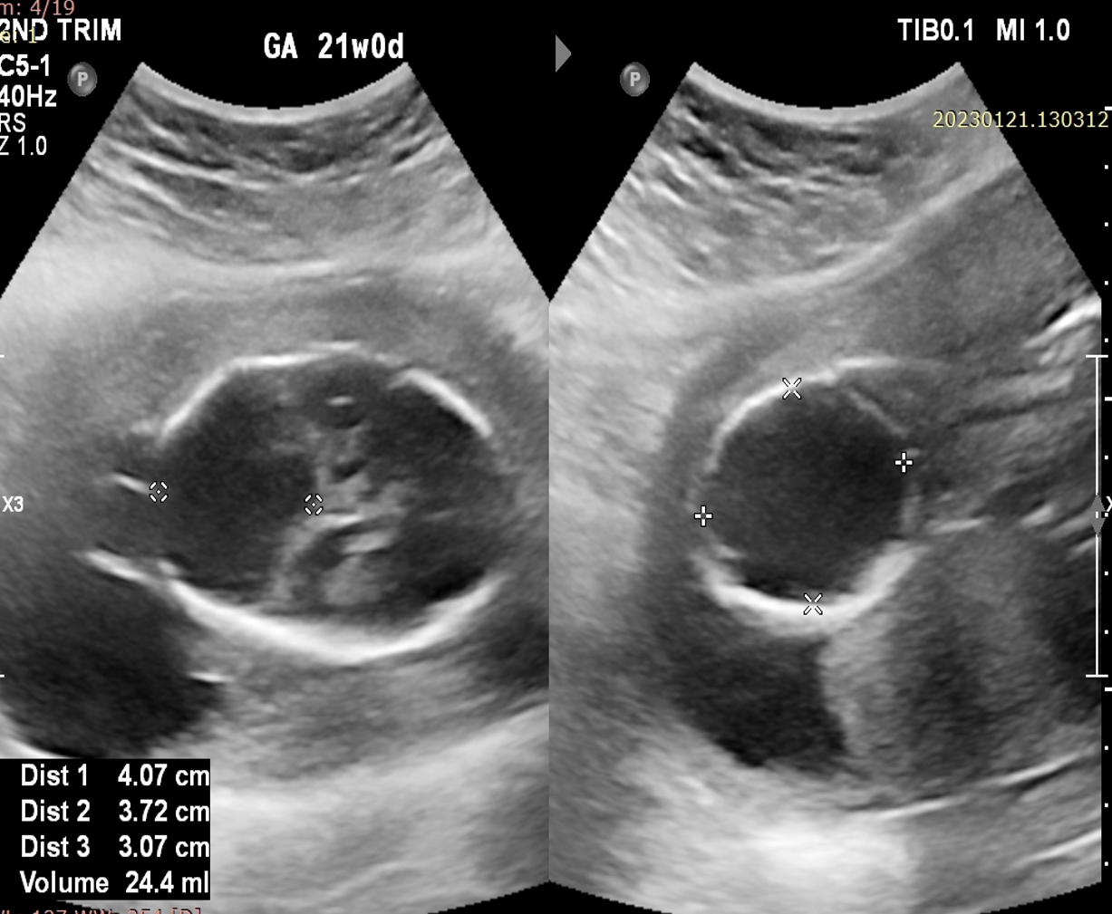
Figure 2: USG showed an enlarged posterior fossa with cystic lesion of size ~ 4.0 x 3.7 x 3.0 cm (violet arrow), cerebellum and vermis not clearly visualized – possibility of Dandy –Walker Malformation/Variant.
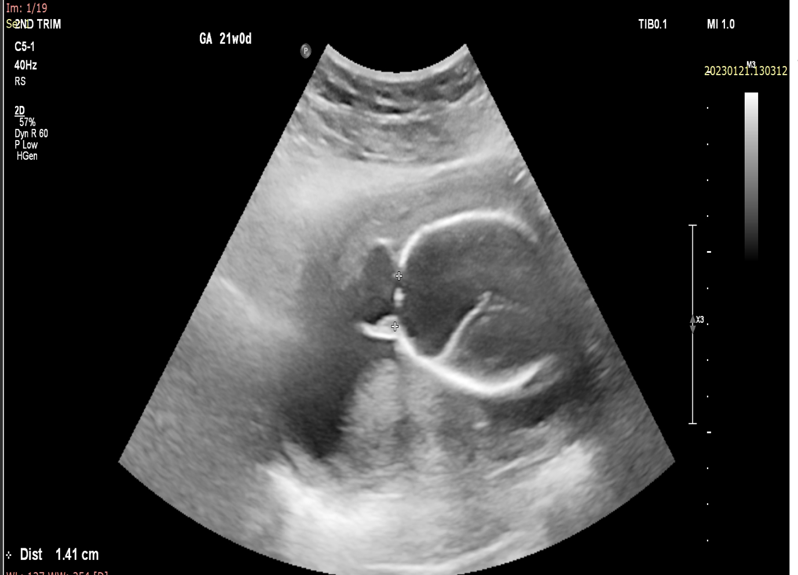
Figure 3: USG showed a defect of size ~ 1.4 cm in the occipital bone (violet arrow).
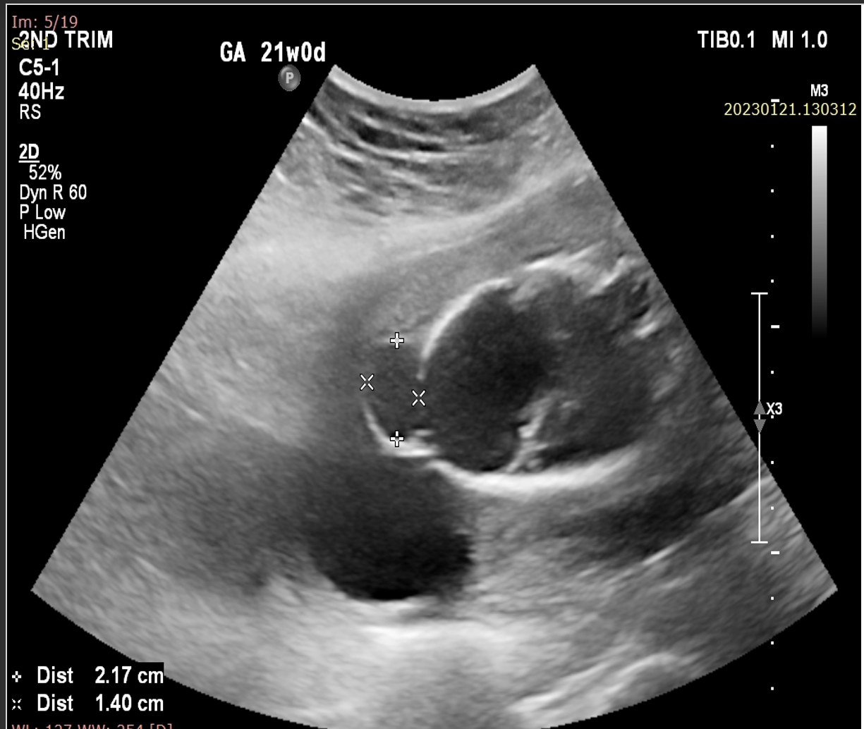
Figure 4: USG showed a herniation of loculated cyst like structure of size ~ 2.1 x 1.4 cm, posteriorly through defect of size ~ 1.4 cm in the occipital bone (violet arrow)– suggestive of occipital meningoencephalocele.
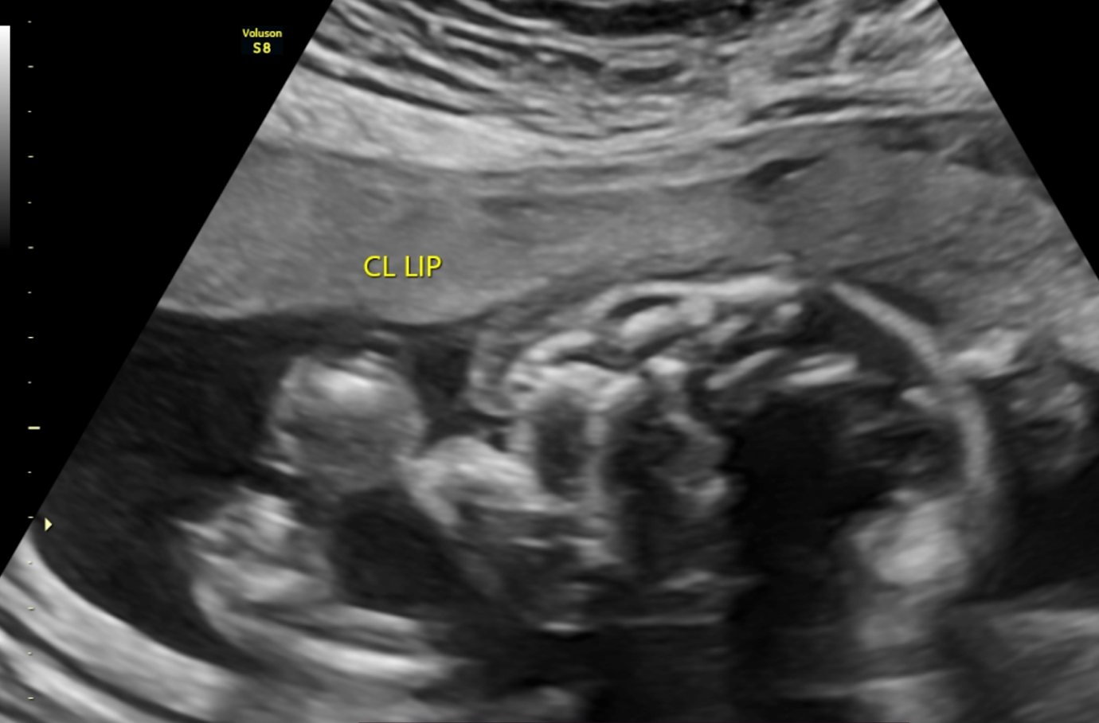
Figure 5 : USG showed a linear defect in the upper lip which is seen extending through the alveolar ridge (violet arrow) – suggestive of cleft lip.
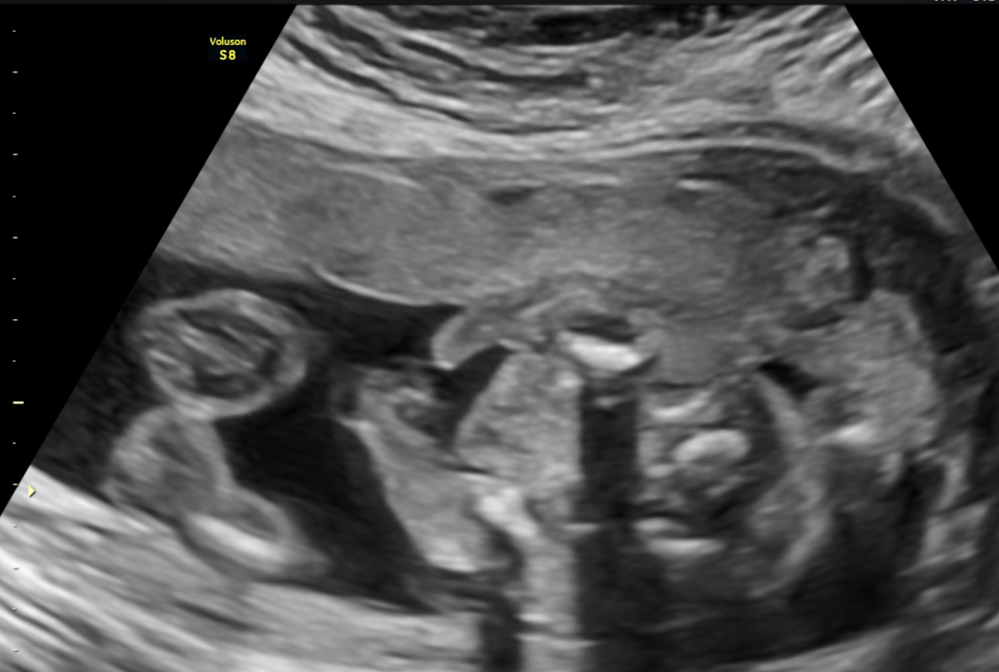
Figure 6 : USG showed a linear defect in the upper lip which is seen extending through the hard palate (violet arrow) – suggestive of cleft palate.
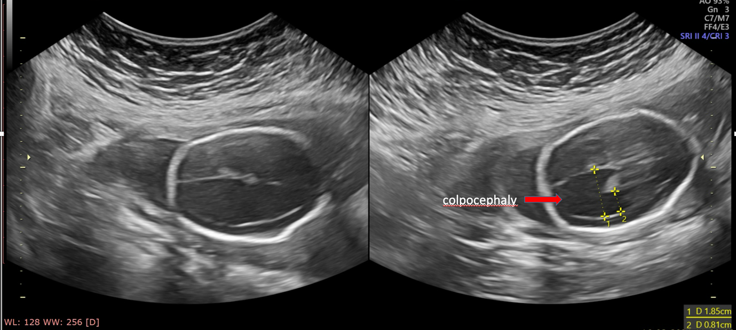
Figure 7: USG shows disproportionate dilatation of the occipital horns of lateral ventricles, with relative narrowing of frontal horns – which is characteristics of colpocephaly (red arrow). There is also increased atrial diameter measuring ~ 1.85 cm, which indicates ventriculomegaly.
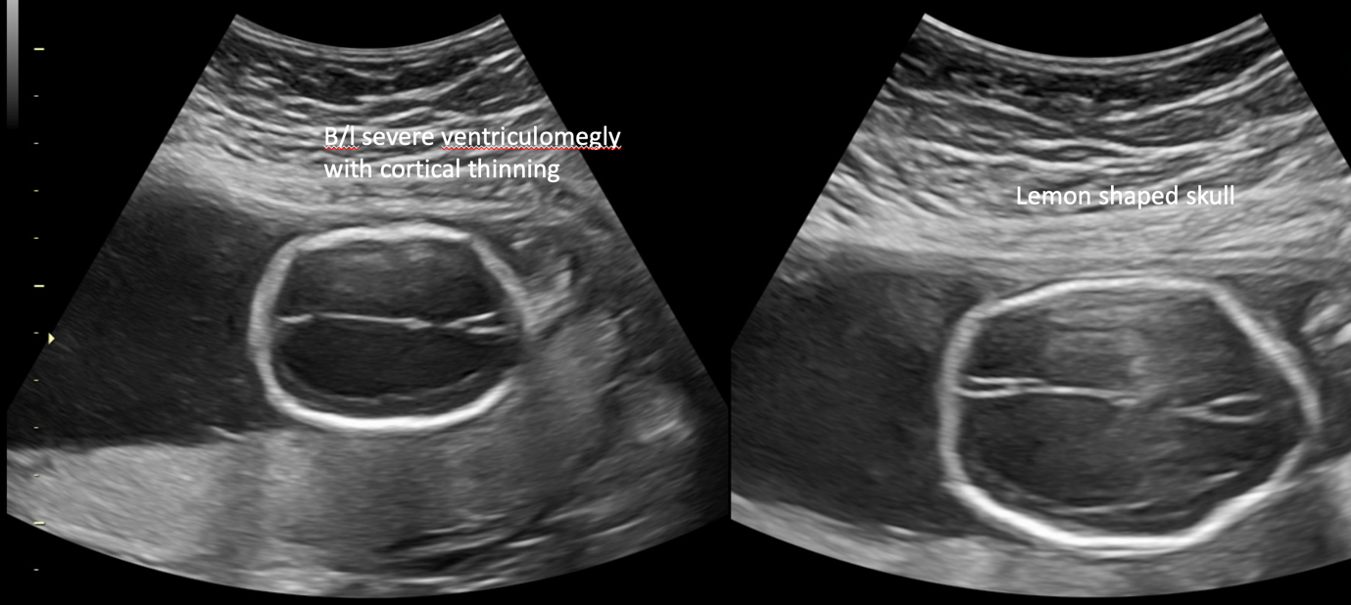
Figure 8: USG shows marked severe dilatation of both ventricles with associated thinning of cortex (violet arrow). The shape of skull is also distorted and resembles “lemon shaped”.
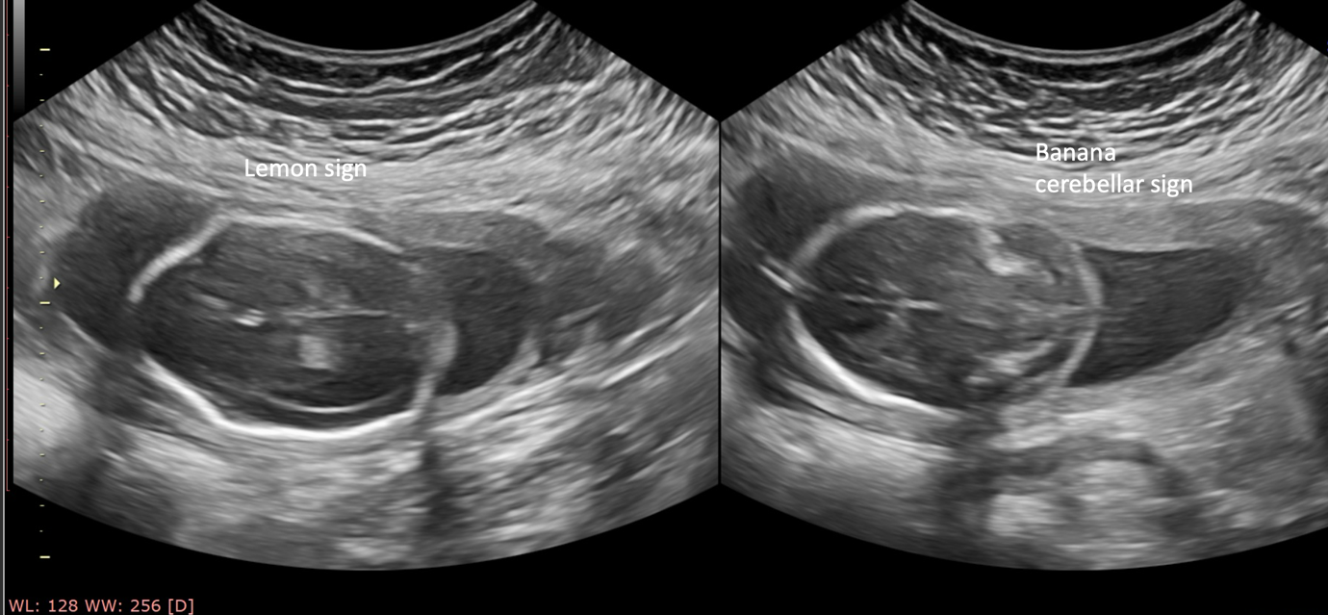
Figure 9: USG shows marked severe dilatation of both ventricles with associated thinning of cortex (violet arrow). The shape of skull is also distorted and resembles “lemon shaped” (violet arrow).
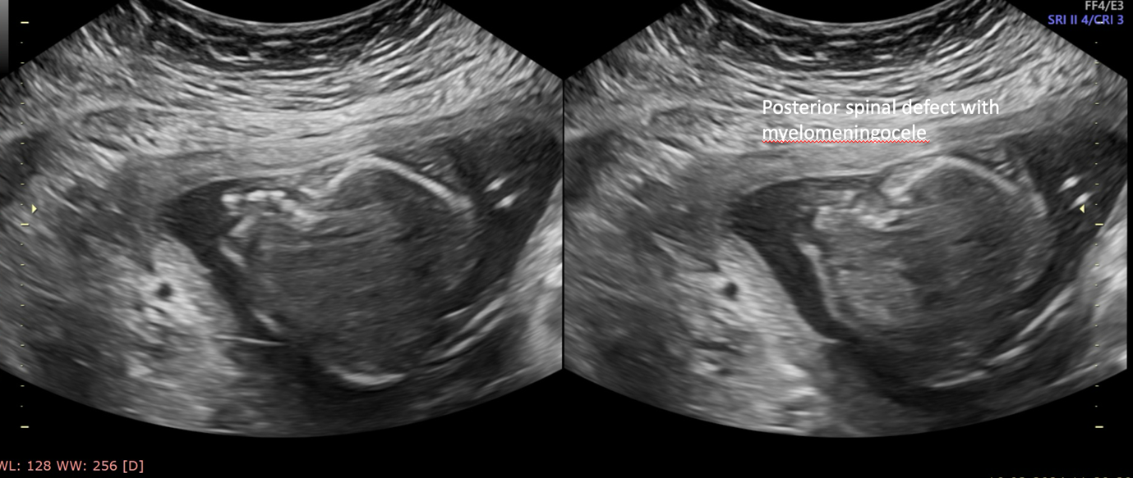
Figure 10: USG shows defect in posterior vertebral elements with a small cystic outpouching from the dorsal aspect of the spine (violet arrow). The sac appears to contain neural tissue, suggesting myelomeningocele rather than simple meningocele.
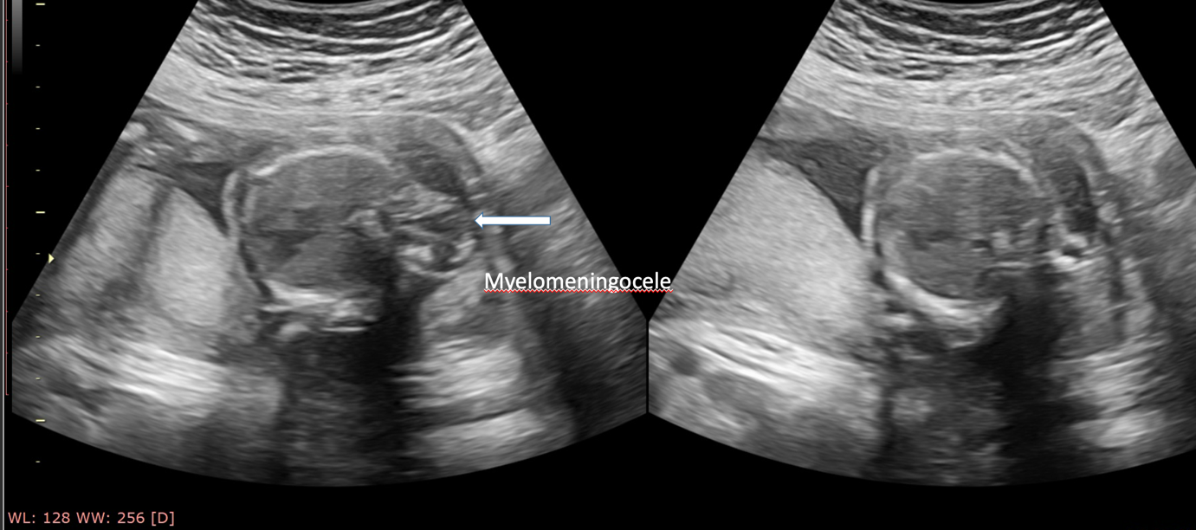
Figure 11: USG shows defect in posterior vertebral elements with a small cystic outpouching from the dorsal aspect of the spine (white arrow). The sac appears to contain neural tissue, suggesting myelomeningocele rather than simple meningocele.
ASSOCIATIONS
Non-syndromic CNS: found in ~ 70% of cases other CNS abnormalities are present, including:
Cortical dysplasia, polymicrogyria, or subependymal grey matter heterotopia.
Dysgenesis of the corpus callosum.
Lipoma of the corpus callosum.
Holoprosencephaly.
Schizencephaly.
Occipital encephalocele: less than 5%.
Lumbosacral meningocele.
Syringomyelia.
Non-syndromic non-CNS: found in ~ 25% of patients:
Cleft palate.
Facial angiomas.
Low-set ears.
Polydactyly or Syndactyly.
Cardiac anomalies.
Polycystic kidneys.
Diaphragmatic hernias.
Syndromic non-aneuploidic associations:
Aicardi syndrome
Coffin-Siris syndrome
Cornelia de Lange syndrome
Fryns syndrome
Hydrolethalus syndrome
Klippel-Feil syndrome
Meckel-Gruber syndrome
Smith-Lemli-Opitz syndrome
Walker-Warburg syndrome
Aneuploidic associations:
Emanuel syndrome
trisomy 18
trisomy 13
triploidy
DIFFERENTIAL DIAGNOSIS:
Other causes and mimics of an enlarged retrocerebellar CSF space including:
MEGA CISTERNA MAGNA –
- Normal 4th ventricle.
- Normal vermis.
- No hydrocephalus.
EPIDERMOID CYST
RETRO-CEREBELLAR ARACHNOID CYST-
- Mass effect with anterior displacement of the cerebellum and the 4th ventricle is characteristic of retro-cerebellar arachnoid cyst.
- No hydrocephalus.
BLAKE’S POUCH CYST-
- normal vermis, not hypoplastic
- normal torcular position
- Tetra-ventricular hydrocephalus
JOUBERT ANOMALY (vermian hypoplasia) – Vermis is small, but has normal appearance.

ISOLATED 4TH VENTRICLE.
GENETIC EVALUATION
- Diagnostic testing (Aminocentesis) with chromosomal microarray analysis (CMA) should be offered to patients when DWM is detected.
- In case of any other additional anomalies suspicion, consanguinity, or a family history of a specific condition, gene panel testing or exome sequencing is sometime CMA does not able to detect single gene (Mendelian) disorders.
- For those patients, who denies diagnostic evaluation, another option of cell-free DNA screening is suggested, however this particular test fails to detect the underlying genetic cause in most cases unless a common aneuploidy is suspected.
DISCUSSION
Dandy-Walker malformation is a rare and heterogenous malformation involving the cerebellar vermis and is characterized by triad of Hypoplasia of vermis, Fourth ventricular cystic dilatation and tentorium cerebelli elevation.
The risk factors include various infections (Rubella, Toxoplasmosis, CMV); and drug exposures (Warfarin, Ethanol, Isotretinoin). In my case, mother was having no any history of any such drug exposure. Dandy-Walker syndrome with various other anomalies can be diagnosed early using high-resolution fetal ultrasound and MRI Scan if needed. In my case, prenatal diagnosis was done through Ultrasonographic analysis.
The first ultrasound clue to the diagnosis is an enlargement of the cisterna magna. Fetal MRI allows a better characterization of this malformation. This pathology is associated with CNS malformations and other genetic diseases, which is why a study of the karyotype and molecular analyzes are suggested. Prenatal diagnosis of Dandy-Walker Malformation cannot predict the prognosis of the disease, on the basis of which the medical team and the parents must make a decision, especially since there is no consensus in the literature.
Ultrasonography study showed an enlarged posterior fossa with cystic lesion of size ~ 4.0 x 3.7 x 3.0 cm, cerebellum and vermis not clearly visualized – possibility of Dandy –Walker Malformation/Variant. There was also a defect of size ~ 1.4 cm in the occipital bone. There was also evidence of a herniation of loculated cyst like structure of size ~ 2.1 x 1.4 cm, posteriorly through defect of size ~ 1.4 cm in the occipital bone which suggests occipital meningoencephalocele. USG also showed a linear defect in the upper lip which is seen extending through the alveolar ridge which suggests cleft lip, and also a linear defect in the upper lip which is seen extending through the hard palate which suggests cleft palate.
More USG findings showed disproportionate dilatation of the occipital horns of lateral ventricles, with relative narrowing of frontal horns which is characteristics of colpocephaly. There is also increased atrial diameter measuring ~ 1.85 cm, which indicates ventriculomegaly. There was severe dilatation of both ventricles with associated thinning of cortex. The shape of skull is also distorted and resembles “lemon shaped”. USG scan also shows a defect in posterior vertebral elements with a small cystic outpouching from the dorsal aspect of the spine. The sac appears to contain neural tissue, suggesting myelomeningocele rather than simple meningocele. These several findings was helpful in prenatal diagnosis of Dandy-Walker Malformation with association of Cleft lip/Cleft palate; posterior spinal defect with myelomeningocele, colpocephaly; and other congenital defects at 21 weeks of gestation.
CONCLUSION
This case focuses on the role of ultrasound in detecting Dandy-Walker Malformation with association of Cleft lip/Cleft palate; posterior spinal defect with myelomeningocele, colpocephaly; and other congenital defects, providing importance for the need of genetic testing and comprehensive counselling in complex fetal anomalies. Multidisciplinary evaluation confirmed the diagnosis; counselling guided for poor prognostic outcome.
REFERENCES:
- Guibaud L, Larroque A, Ville D, Sanlaville D, Till M, Gaucherand P, et al. Prenatal diagnosis of ‘isolated’ Dandy-Walker malformation: Imaging findings and prenatal counselling. Prenat Diagn. 2012;32(2):185-93.
- D’Antonio F, Khalil A, Garel C, Pilu G, Rizzo G, Lerman-Sagie T, et al. Systematic review and meta-analysis of isolated posterior fossa malformations on prenatal imaging (part 2): Neurodevelopmental outcome. Ultrasound Obstet Gynecol. 2016;48(1):28-37.
- Shekdar K. Posterior fossa malformations. Semin Ultrasound CTMR. 2011;32(3):228-41.
- Babcook CJ, Chong BW, Salamat MS, Ellis WG, Goldstein RB. Sonographic anatomy of the developing cerebellum: Normal embryology can resemble pathology. AJR Am J Roentgenol. 1996;166(2):427-33.
- Benda CE. The Dandy-Walker syndrome or the so-called atresia of the foramen Magendie. J Neuropathol Exp Neurol. 1954;13(1):14-29.
- Osenbach RK, Menezes AH. Diagnosis and management of the DandyWalker malformation: 30 years of experience. Pediatr Neurosurg. 1991;18(4):179-89.
- Mohamed R, Hamza Z, Nisrine M, Sanae E, Chahrazed B, Abdelaziz B, et al. Syndrome de dandy-walker: Du diagnostic antenatal a la prise en charge therapeutique. (Apropos de 3 cas et revue de la literature) Int J of Adv Res. 2020;8(3):195-204.
- Harper T, Fordham LA, Wolfe HM. The fetal Dandy Walker complex: Associated anomalies, perinatal outcome and postnatal imaging.Fetal Diagn Ther.2007;22(4):277-81.
- Salihu HM, Kornosky JL, Druschel CM. Dandy-Walker syndrome, associated anomalies and survival through infancy: A population-based study. Fetal Diagn Ther. 2008;24(2):155-60.
- Murray JC, Johnson JA, Bird TD. Dandy-Walker malformation: Etiologic heterogeneity and empiric recurrence risk. Clin Genet. 1985;28(4):272-83.
- Laing FC, Frates MC, Brown DL, Benson CB, Di Salvo DN, Doubilet PM. Sonography of the fetal posterior fossa: False appearance of Mega-Cisterna magna and Dandy-Walker variant. Radiology. 1994;192(1):247-51.
- Ichizuka K, Mishina M, Hasegawa J, Matsuoka R, Sekizawa A, Pooh RK. Diagnosis of a case of Dandy-Walker malformation aided by measurement of the brainstem-vermis angle at 14 weeks gestation. J Obstet Gynaecol Res. 2015;41(5):790-3.
- Ecker JL, Shipp TD, Bromley B, Benacerraf B. The sonographic diagnosis of Dandy-Walker and Dandy-Walker variant: Associated findings and outcomes. Prenat Diagn. 2000;20(4):328-32.
- Dashe, J. S., & Norton, M. E. (2024). Prenatal diagnosis of CNS anomalies other than neural tube defects and ventriculomegaly. UpToDate. Retrieved April 6, 2025.
- Hart, M. N., Malamud, N. & Ellis, W. G. (1972). The Dandy-Walker syndrome. Neurology, 22 (8), 771-780.

AJPHR is
- Peer-reviewed
- monthly
- Rapid publication
Submit your next manuscript at
editor@ajphr.com / editor.ajphr@gmail.com

