
Research Article
AMERICAN JOURNAL OF PHARMACY AND HEALTH RESEARCH
www.ajphr.com
2026, Volume 14, Issue 04
ISSN: 2321–3647(online)

Détermination of effect of Ethanolic extract of Gomphrena Celosioides on markers of cellular immunity.

Dr GOGAHY Konan^{1*}, Dr Vanié Bi Irié Germain², Dr MIEZAN Bilé Aka Patrice¹, Prof Yapi Houphouet Félix³, Prof SAKI Suomion Justin²
1.Biochemistry Laboratory, Faculty of Biological Sciences, Péléforo GON Coulibaly University of Korhogo, Côte d'Ivoire.
2.Biotechnology, Agriculture and Biological Resource Valorization Laboratory, Faculty of Biosciences, FELIX Houphouet Boigny University of Abidjan Cocody. - Côte d'Ivoire
3. Laboratory of Biochemical Pharmacodynamics, Faculty of Biosciences, Felix Houphouet Boigny University of Abidjan Cocody.

ABSTRACT
Gomphrena celosioides is a plant used in many traditional medicine recipes in West Africa, Southeast Asia, and South America. The present study aimed to evaluate the cellular immune response induced by the ethanolic extract of Gomphrena celosioides. The acute toxicity study of the extract used, conducted in rats according to OECD guideline no. 423, showed that the extract is non-toxic. The effect of the extract on cellular immunity markers was obtained in rats by measuring white blood cells, CD4+ T lymphocytes, neutrophils, and total lymphocytes. The absolute counts of these cells were determined by flow cytometry phenotyping. This study showed that the ethanolic extract of Gomphrena celosioides significantly increases the number of white blood cells, neutrophils and CD4+ T lymphocytes, thus suggesting an immunostimulatory action of this extract in rats.
Keywords: Gomphrena celosioides, ethanolic extract, acute toxicity, cellular immunity markers, immunostimulant

*Corresponding Author Email: gogahykon2@gmail.com
Received 10 March 2026, Accepted 13 April 2026

INTRODUCTION
Immunity is a set of defense mechanisms in an organism. The immune system is one of the best-known of these defense mechanisms in our body. It consists of a set of organs, tissues, and cells whose function is to protect the organism by identifying and destroying extrinsic (viruses, bacteria) or intrinsic (cancer cells) foreign particles [1]. The course of an immune response comprises two essential phases: the non-specific immune response, or primary response, is the natural, innate immunity, which is rapidly established to maintain the integrity of the organism; and the specific or adaptive immune response, which is directed according to the type of antigen, resulting in a humoral or cell-mediated immune response. This immune system forms a precarious balance which can lead to pathologies when it malfunctions, such as dysimmune diseases in the case of hyperactivation or cancers in the case of a lack of immunovigilance [12].
Plants are increasingly used to extract physiologically and biologically active substances that exert a powerful influence on our immune defenses. Some stimulate immunity and help it fight disease, while others calm it when it is overactive.
Gomphrena celosioides, a plant native to Ivory Coast, is used in many traditional medicine recipes traditionnelle [14] [16]. Several studies have been conducted on the biological properties of various extracts from this plant. The described biological activities are highly varied: analgesic [4], antipyretic [7], cardioprotective, and hepatoprotective [10]. The present work aims to evaluate the cellular immune response induced by the ethanolic extract of Gomphrena celosioides by measuring white blood cells, CD4+ T lymphocytes, total lymphocytes and neutrophil granulocytes in rats.
MATERIALS AND METHOD
Ethanolic extract
One hundred (100 g) of dry powder of Gomphrena celosioides, from the Amaranthaceae family, is macerated in 1000 mL of 70% ethanol for 24 hours. The homogenate is filtered three times through absorbent cotton and then once through Wattman filter paper. The filtrate is then evaporated under vacuum at 50°C in an oven. This yields a powder that constitutes the ethanolic extract [5]. The powder was stored in a refrigerator in sterile, hermetically sealed glass tubes.
Acute Toxicity
The experiment was conducted in accordance with OECD Guideline No. 423 for the testing of chemical substances.
Nine (9) female Wistar rats, aged 10 to 11 weeks and weighing between 82 and 109 g, were used for the experiments. The selected rats were nulliparous and non-pregnant. Two (2) groups of three (3) rats each were formed. Group 1 (control) received physiological saline (0.9% NaCl). Group 2 received the ethanolic extract of Gomphrena celosioides at a dose of 2000 mg/kg body weight (BW). The animals were observed for 48 hours. After this observation period, a third group of three (3) rats was administered a dose of 5000 mg/kg BW of the extract. All animals treated orally with the different solutions are observed daily for fourteen (14) days.
PARAMETERS OF CELLULAR IMMUNITY
The immune markers considered in this study are: white blood cells, neutrophils, total lymphocytes, and CD4+ T lymphocytes
Experimental Animals
Twenty-four (24) Wistar rats, aged eight (8) to nine (9) weeks, were used for the tests. The animals were divided into four (4) homogeneous groups of six (6) animals per group (three (3) males and three (3) females) and treated intraperitoneally with the different solutions. Group 1 received physiological saline, 0.9% NaCl. Group 2 was treated with 200 mg/kg BW of an ethanolic extract. Groups 3 and 4 (reference groups) were treated with 15 mg/kg BW of methylprednisolone (an immunosuppressive molecule) and 50 mg/kg BW of isoprinosine (an immunostimulatory molecule), respectively. The solutions were administered daily for one week. On the seventh day, blood samples were taken from the animals and used for the quantitative determination of immune cells.
White blood cell, neutrophil granulocyte, and total Lymphocyte count
The animals' whole blood is placed in the continuous flow cell of the Sysmex-XT-2000i. Each cell passes individually through the semiconductor laser beam. The Sysmex-XT-2000i, connected to a graphics printer, prints the absolute numbers of white blood cells, neutrophils, and total lymphocytes onto paper.
CD4+ lymphocyte count
The absolute counts of CD4+ T lymphocytes are determined by flow cytometry phenotyping. Fifty microliters (50 μL) of whole blood are added to ten microliters (10 μL) of Tritex in a Trucount™ tube. The mixture is vortexed and then incubated in the dark for fifteen (15) minutes. Five hundred microliters (500 μL) of the lysis solution are added to the mixture. The entire system is shaken and incubated in the dark for fifteen (15) minutes. The reading is taken using a flow cytometer (Facs Calibur type).
Statistical analysis
The results are expressed as mean values accompanied by the Standard Error of the mean (SEM). Graphical representations of the data were generated using GraphPad Prism 5.0 software (Microsoft USA). Statistical analysis of the results was performed using one-way ANOVA. Differences between means, determined according to Dunnett's test, were statistically significant at a p-value < 0.05.
RESULTS
ACUTE TOXICITY
Clinical Signs and Mortality Rates
Animals treated with the 2000 mg/kg BW dose of the ethanolic extract of Gomphrena celosioides had soft stools between days 2 and 6, while those treated with 5000 mg/kg BW of the same extract suffered from diarrhea and loss of appetite from days 1 to 4. No other changes in the animals' general physical appearance were observed. No rats died during the entire experiment.
Lethal Dose 50 (LD50)
Acute toxicity is a qualitative and quantitative analysis of the irreversible alteration of vital functions after a single administration of a substance, within a period of a few minutes to a few weeks (2 to 4 weeks). It allows the lethal dose 50 (LD50) to be expressed, which provides a measure of the acute or immediate toxicity of a chemical product [18]
The results showed no lethality following oral administration of the 2000 mg/kg BW dose and the limit dose (5000 mg/kg BW) of the ethanolic extract of Gomphrena celosioides. This means that the oral LD50 is higher than these two doses. The LD50 of the ethanolic extract of Gomphrena celosioides is therefore greater than 5000 mg/kg body weight. This result allows the ethanolic extract of Gomphrena celosioides to be classified in category 5 of the Globally Harmonized System (GHS) of chemicals, a category that characterizes substances with low oral toxicity [13].
Other studies have shown a lethal dose of 12200 mg/kg BW orally with the aqueous extract of Gomphrena celosioides in rats. However, these authors' work only concerned the leaves of this plant. For our study, all parts of the plant were used except the roots, since the traditional use of this plant in Côte d'Ivoire, according to our surveys, rarely involves the roots. This shows that toxicity is a relative concept and varies depending on the part of the plant used for the extract, the quantities administered, environmental factors, and the methods of preparation and administration of the herbal medicinal product. Individual factors can modify absorption, distribution, excretion, metabolic transformations, and receptor sensitivity in the target organ [19].
Parameters of cellular immunity
Quantitative analysis of blood cell and CD4+ T lymphocyte parameters after intraperitoneal administration of a 200 mg/kg BW dose of the ethanolic extract of Gomphrena celosioides yielded the results shown in Figures 1, 2, 3, and 4.
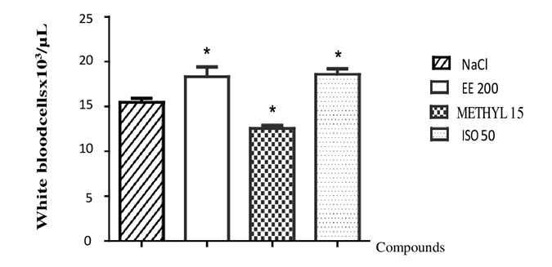
Figure 1: Effects of the ethanolic extract of Gomphrena celosioides, isoprinosine, and methylprednisolone on leukocyte counts in rats
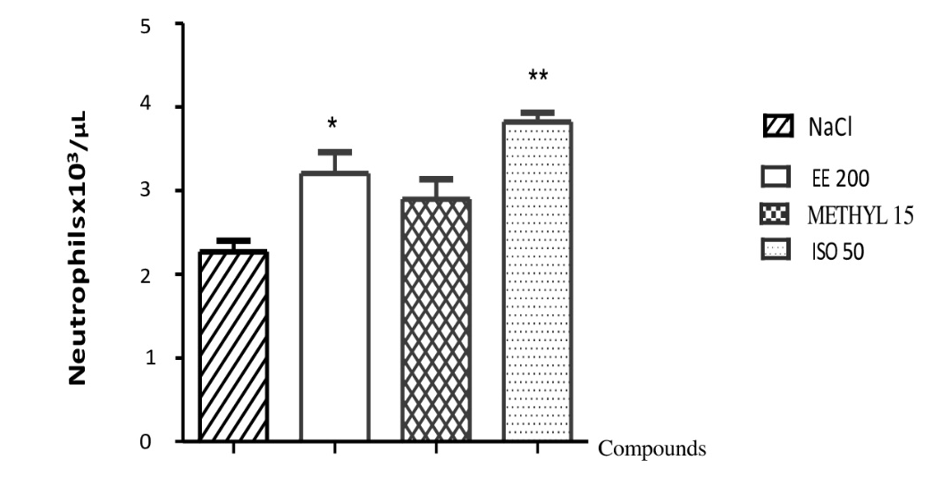
Figure 2: Effects of the ethanolic extract of Gomphrena celosioides, isoprinosine, and methylprednisolone on neutropenic granulocyte counts in rats

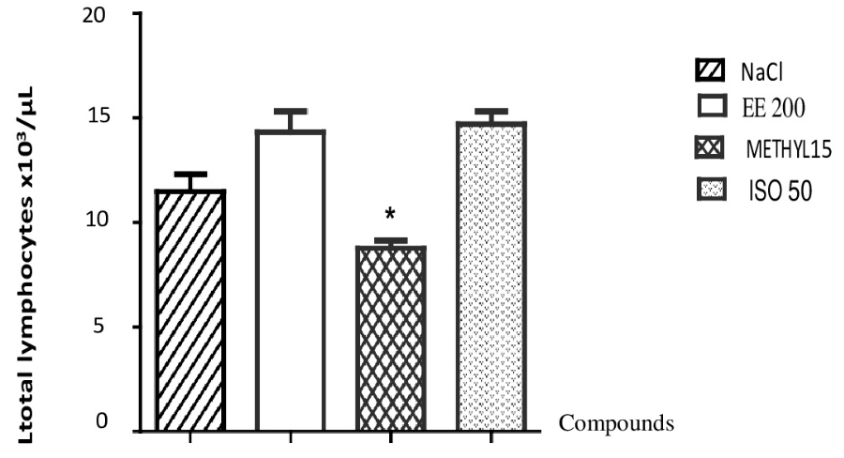
Figure 3: Effects of the ethanolic extract of Gomphrena celosioides, isoprinosine and methylprednisolone on total lymphocyte levels in rats.
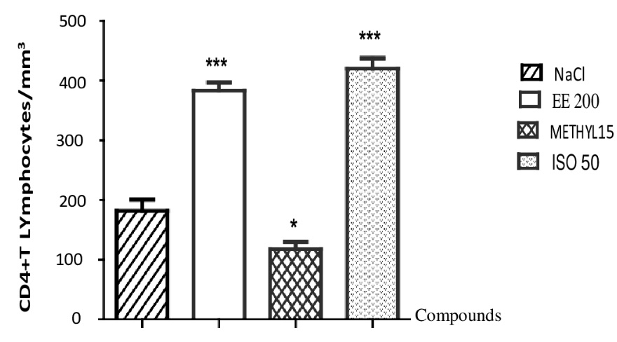
Figure 4: Effects of the ethanolic extract of Gomphrena celosioides, isoprinosine, and methylprednisolone on CD4+ T lymphocyte levels in rats
EE 200: Ethanolic extract 200 mg/kg BW . of Gomphrena celosioides
ISO 50: Isoprinosine 50 mg/kg BW.
Methyl 15: Methylprednisolone 15 mg/kg BW.
* P < 0.05 ; ** P < 0.01 ; *** P < 0.001
DISCUSSION
The results of the cellular immunity study showed that the ethanolic extract of Gomphrena celosioides significantly increases the number of white blood cells, neutrophils, and CD4+ T lymphocytes, similar to isoprinosine, the reference molecule.
Isoprinosine is an immunomodulator [2] that stimulates the immune system by increasing the production of interleukins (IL-1, IL-2) and the number of blood mononuclear cells in patients [11] [20]. The increase in defense cells by Gomphrena celosioides cannot be attributed to false leukocytosis because most current analyzers, equipped with scatter plots that detect abnormalities, report them when they are in large quantities: superimposed points in the lymphocyte region are observed [21] [17] [15] [9].
The increase in the neutrophil granulocyte count reflects the role of Gomphrena celosioides in inducing the body's non-specific, innate immune response. In this process, Gomphrena celosioides stimulates leukocyte proliferation through its constituents, such as flavonoids [6]. Several types of flavonoids, by strengthening the immune system through their antioxidant, anti-inflammatory, and immunostimulatory effects, stimulate leukocyte proliferation and the production of interleukin-2, and significantly increase the activities of T helper lymphocytes, cytokines, interferon-γ, and macrophages.
Stimulation of CD4+ T lymphocyte production would indicate the induction of a specific immune response by Gomphrena celosioides. Once activated, these CD4+ T cells orchestrate the immune response by secreting various cytokines, including interferon-gamma (IFN-γ), interleukin-2 (IL-2), and Tumor Necrosis Factor α (TNF-α) ) [8].
These results suggest that the ethanolic extract of Gomphrena celosioides exhibits immunostimulatory activity.
These results suggest that the ethanolic extract of Gomphrena celosioides may have an immunostimulatory effect. Methylprednisolone (the reference immunosuppressive molecule), on the other hand, significantly lowers the levels of white blood cells and CD4+ T lymphocytes. However, it only slightly increases the number of neutrophils. These results are explained by the fact that glucocorticoids like methylprednisolone increase the number of white blood cells as soon as they are initiated. This increase is primarily due to neutrophils (polymorphonuclear leukocytes).
CONCLUSION
The ethanolic extract of Gomphrena celosioides is non-toxic. It appears to stimulate cellular immunity. This plant could therefore strengthen the body's cellular immune defenses and, as such, be classified as an immune stimulating plant, helping the body respond to stressors and imbalances. However, counting CD8+ T lymphocytes involved in this cellular immunity, in addition to CD4+ T lymphocytes, could further support the results of our work.
DISCLOSURES
Authors agreed on the work and the results. They declared that no competing interests exist.
REFERENCES
- Aldea M. et al. How to manage patients with corticosteroids in oncology in the era of immunotherapy? Eur J Cancer (2020)
- Campoli-Richards DM, Sorkin EM, Heel RC (1986): Inosine Pranobex. A preliminary Review of its Pharmacodynamic and Pharmacokinetic Properties and Therapeutic Efficacy. Drugs 32, 383–424.
- de Moura R.M., Pereira P.S ., Januário A.H., França S.C., Dias D.A. (2004). Antimicrobial screening and quantitative determination of benzoic acid derivative of Gomprena celosioides by TLC-densitometry. Chem Pharm Bull., 52(11): 1342 – 1344.
- Gessler M., Nkunya M., Mwasumbi L., Heinrich M., Tanner M. (1994). Screening Tanzanian medicinal plants for antimalarial activity. Acta Trop., 56: 65 -77
- Guédé - Guina F., Manda M. V., Harouna D. (1993). Proteins of MISCA a plant source concentrate against fungi. J Ethnopharmacol., 105: 30 -45.
- Kawakita S. W., Giedlin H.S., Nomoto K. (2005). Immunomodulators from higher plants. J Nat., 46: 34 – 38.
- Latifou L. (2005). Etude phytochimique et activité biologique de substances naturelles isolées de plantes béninoises. Université Louis Pasteur Strasbourg. Faculté de Pharmacie, PARIS, 280 p.
- Lucey D.R ., Clerici M., Shearer G.M. (1996).Type 1 and type 2 cytokine dysregulation in human infectious, neoplastic, and inflammatory diseases. Clin Microbiol Rev., 9:532 – 562.
- Maufras T. (2019). Nuage de points provenant du « DIFF » du sysmex – XT- 2000Iv à partir de sang de chien. Thèse de Doctorat. Toulouse 3 – 4040.
- Maxime M.S., Bale B., Mama A.B., Jean M.A., Karim L.D. (2012). Composition chimique de l’extrait aqueux de Gomphrena celosioides Mart et étude de ses effets toxicologiques chez le foie du rat Wistar. Rev ScLib Ed Mers., 4: 2111 - 4706.
- Nakamura T, Miyasaka N, Pope RM, Talal N, Russel IJ (1983): Immunomodulation by isoprinosine effects on in vitro immune functions of lymphocytes from humans with autoimmune diseases. Clin. Exp. Immunol. 52, 67–74.
- Oakley R.H. et al. The biology of the glucocorticoid receptor: new signaling mechanisms in health and disease. J Allergy Clin Immunol (2013)
- OCDE. (2001). Lignes directrices de l’OCDE pour les essais de produits chimiques. Toxicité orale aiguë - Méthode par classe de toxicité aiguë. 14p.
- Onocha P.A., Ajaiyeoban E.O., Dosumu O.O., Ekundayo O. (2005). Phytochemical screening and Biological Activities of Gomphrena celosioides (C. Mart) extracts. Nigerian Soc Exp Biol J.,5: 59 -67.
- Schrezenmeier H., Muller H., Gunsilius E., Heimpel H.& Seifried E. (1995) Anticoagulant‐induced pseudothrombocytopenia and pseudoleucocytosis. Thrombosis Haemostasis 73, 506 – 513
- Sharma N., Tanwer BS.,Vijayvergia R. (2011). Study of primary metabolites and antimicrobial activities of Digera muricata (L.) Mart. J Chem Pharm Res., 3(2): 424-443
- Solanki D.L.& Blackburn B.C.(1983) Spurious leukocytosis and thrombocytopenia. A dual phenomenon caused by clumping of platelets invitro. Journal of the American Medical Association 250, 2514 – 2515.
- Trevan J.W. (1927). The error of determination of toxicity. Proc Roy Soc., 10: 483 – 514.
- Tron I., Piquet O., Baert A. (2002).Toxon. Manuel de toxicologie. Agence de l’environnement et de la maîtrise de l’énergie: 26 - 27; 32 - 34.
- Tsang KY, Pan JF, Swanger DL, Fudenberg HH (1985): In vitro restoration of immune responses in aging humans by isoprinoisne. Int. J. Immunopharmacol. 7, 199–206. https://doi.org/10.1016/0192-0561(85)90027-X
- Zandecki M., Genevieve F., Gerard J., Godon A. (2007) Spurious counts and spurious results on haematology analysers: a review. Part II: white blood cells, red bloodcells, haemoglobin, red cell indices and reticulocytes. International journal of laboratory hematology 29/1, 21- 41.

AJPHR is
- Peer-reviewed
- monthly
- Rapid publication
Submit your next manuscript at
editor@ajphr.com / editor.ajphr@gmail.com

